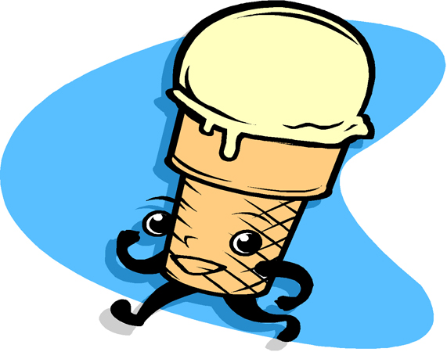
It is Hot
By Clark Ness www.clarkness.com

“Mom, it is hot out here in the yard,” said Madison on a hot summer day.
“If you are hot, then use the magic nickel to cool yourself off,” said Madison’s mother who was weeding her flowers.
Madison went and got the magic nickel.
“I need to think about how I could cool off,” she said to herself. “I have got it. Ice cream, ice cream, ice cream.”
Poof! Madison was an ice cream cone. She was just nine inches tall. She still had two legs and two arms.
“Oh, that feels a lot better,” she said. “Look, Mom. I feel cooler now.”
Madison’s mother looked up from her flowers. “Oh, I see you are an ice cream cone. Have fun,” said Madison’s mother.
Madison was a lot cooler. She went about the yard looking at the trees and flowers. She stopped and looked at a big red flower. She looked down and there were a lot of ants.
“Hello, ants,” said Madison. The ants looked up.
“Are you made of ice cream?” asked one of the ants.
“Yes, I am, and I feel so cool on this hot day,” said Madison.
The ant made some ant sounds, and about 500 ants came over by Madison.
“We would like to show you our ant nest,” said the first ant.
“Ok,” said Madison.
The ants all picked up Madison and took her to their nest. Madison was too big to go into the nest so they sat her down next to the nest’s opening. The ants got all around her. They began to sing to her ant songs.
A drop of melted ice cream fell from Madison’s ice cream hair. The ants cheered and many took a lick of the sweet ice cream.
“Thank you, thank you, thank you,” yelled the ants.
Madison was happy that the ants liked the ice cream. She shook her head and drops of melted ice cream rained down on the ants. The ants went crazy licking the ice cream.
A big ant came up to Madison. It was the queen ant.
“Thank you for giving us some of your ice cream. You are a very nice ice cream cone. Please come back and see us again,” said the queen ant.
“I am glad you all like ice cream. I will come back and see you again,” said Madison. “Now, I need to turn back into a girl.”
Madison shook her head one more time. Many drops of ice cream came down on the ants. The ants cheered and cheered.
Madison took the magic nickel and said, “Madison, Madison, Madison.”
Poof! Madison was Madison the girl again. She walked away from the ants’ nest and went to tell her mother about the nice ants in their yard.

Flesch-Kincaid Grade Level - 2.9
Flesch Reading Ease - 89.5

Text Copyright © 2008 by Clark Ness. Clip art from Microsoft Clip Art.
Permission granted for reprinting and photocopying.
Sale of this story and clip art is prohibited.

More free stories and books are available at www.clarkness.com.

