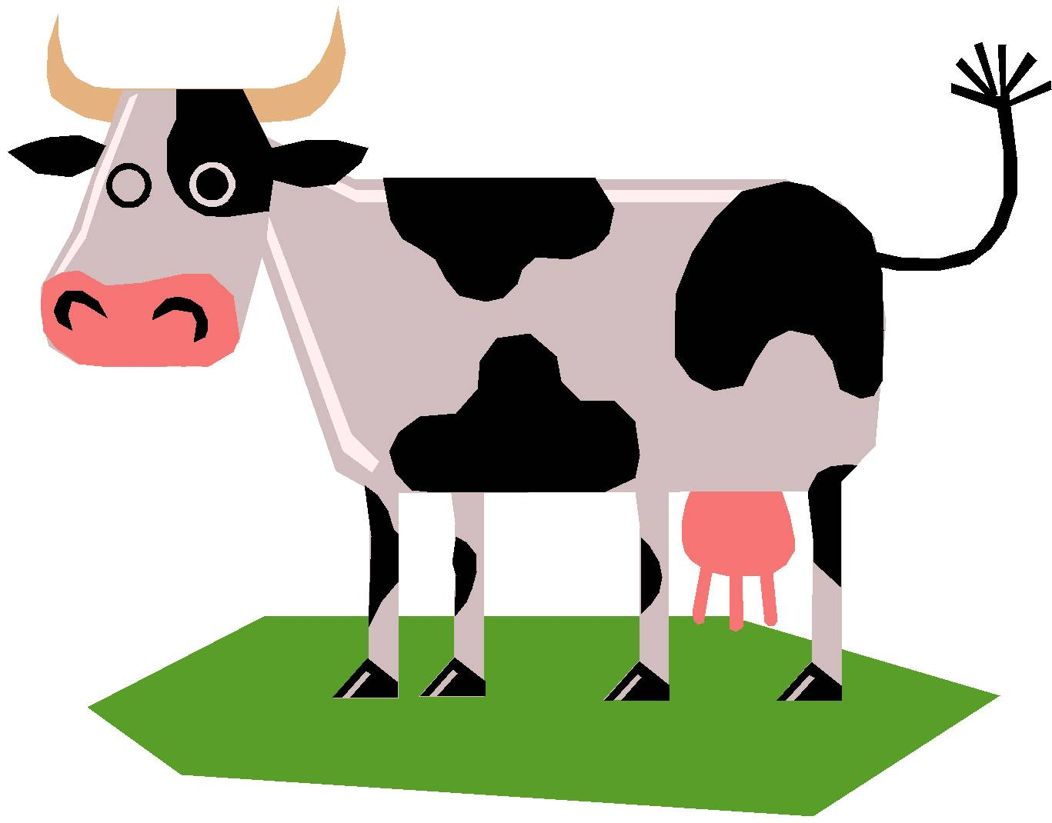
Emily the Cow
By Clark Ness www.clarkness.com

One day when Emily got up she went to her mother.
“Mom, I want to be a cow,” she said.
“Well, OK. If you want to be a cow, you can be a cow,” said Emily’s mother. “Just be a cow after breakfast and before lunch.”
Emily ate a big breakfast and then got dressed. She got her magic nickel and went outside.
She took the magic nickel into her hand and said, “Cow, cow, cow.” Poof! Emily was a cow. She was a black and white cow.
“Moo,” said Emily the cow. “This is grand. I am a real cow. With that, Emily took a little run in her yard.
“Moo,” said Emily the cow again. “I think that I want to be a jumping cow.” She looked in the yard and saw her dog. She ran at her dog and then jumped over him. She did it.
“Yes, I can jump,” said Emily the cow. She looked at the yard’s fence. She ran at the fence and jumped over it.
“Yes!” said Emily the cow. She then saw her mother’s car. She ran at the car and jumped over it.
“Yes!” said Emily the cow. She looked at her home. She ran at it. She did it. She had jumped over her home.
“Yes!” said Emily the cow. She looked at her street. She ran at it and jumped over it. She jumped so high that she landed at her school.
“Yes!” said Emily the cow. She then looked up in the sky and saw a jet airplane.
“I think I can do it,” said Emily the cow. She took a hard run and jumped. Up, up, up she went and over the jet airplane. She landed back at her home.
“Yes! That was cool,” said Emily the cow. She looked around again.
“What can I jump over?” she asked. She looked up in the sky and saw the moon. “That is what I want to jump over.”
She took a hard, hard run and jumped. Up, up, up, up, up, up, she went and then up, up, up, up, up, up, some more. Soon the earth was a small ball, and the moon was getting bigger and bigger. Up, up, and up she went.
Then it happened, Emily the cow was over the moon. Down, down, down she fell. The moon soon got smaller and smaller and the earth got bigger and bigger. In no time, she had landed back at her home.
“Yes! I jumped over the moon,” said Emily the cow.
“Emily, lunch,” said her mother.
Emily the cow got her magic nickel. “Emily, Emily, Emily,” she said.
Poof! Emily was Emily again. “I think it was grand to be a cow,” said Emily, and she went to lunch.

Flesch-Kincaid Grade Level - 2.4
Flesch Reading Ease - 90.5

Text Copyright © 2008 by Clark Ness. Clip art from Microsoft Clip Art.
Permission granted for reprinting and photocopying.
Sale of this story and clip art is prohibited.

More free stories and books are available at www.clarkness.com.

