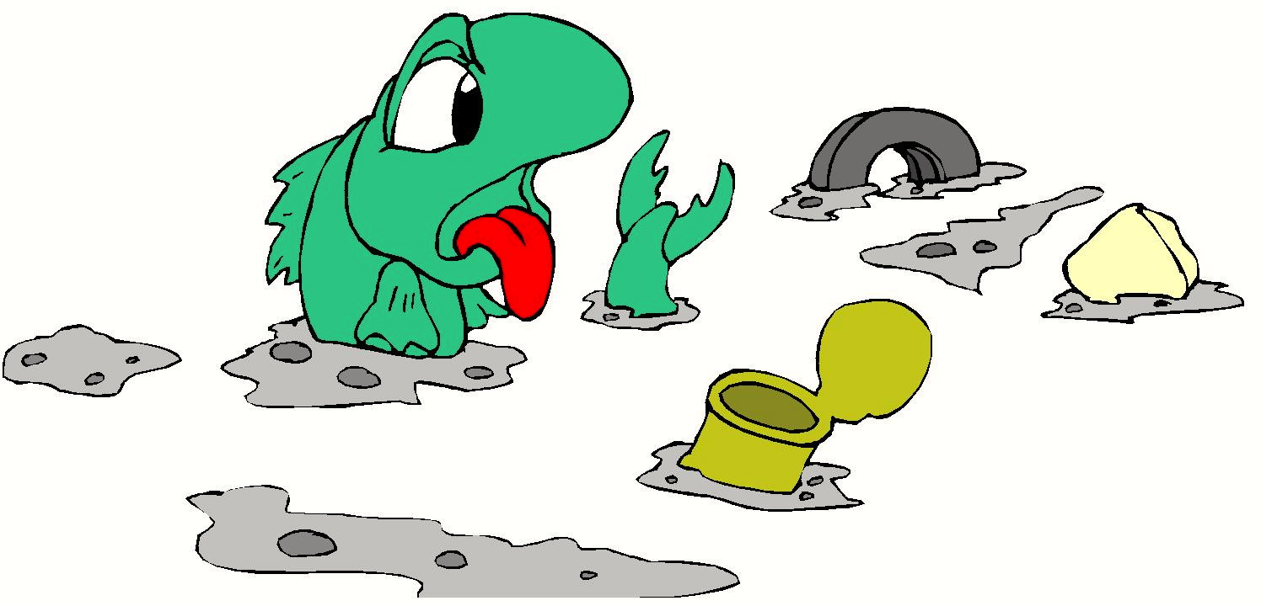


Trash in the Creek
I see trash in the creek.
It can stink. It can reek.
Trash shouldn’t go in the creek.
Story level 15. More free stories and ebooks available at www.clarkness.com and www.readinghawk.com.
Text Copyright © 2014 by Clark Ness. Images from Microsoft Office Images unless otherwise noted. Permission is granted for printing, photocopying, emailing, recording, storing in a retrieval system, and transmitting this story in any form, or by any means, mechanical and/or electronic. Sale of this story and/or uploading it to a commercial bookstore or commercial website is strictly forbidden without prior written permission.

