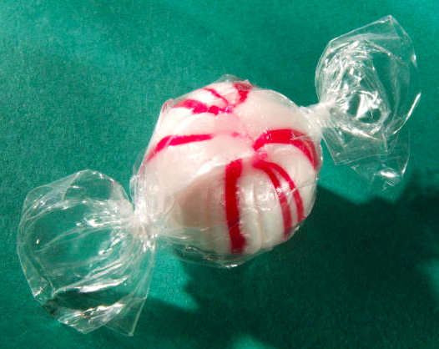


This Mint
“I see 1 mint,” said Dee.
“This mint is Sam’s mint,” said Dee.
“This mint is 1 sweet mint,” said Sam.
Sam is happy that he has 1 sweet mint.
Story level 11. More free stories and ebooks available at www.clarkness.com and www.readinghawk.com.
Text Copyright © 2014 by Clark Ness. Images from Microsoft Office Images unless otherwise noted. Permission is granted for printing, photocopying, emailing, recording, storing in a retrieval system, and transmitting this ebook in any form, or by any means, mechanical and/or electronic. Sale of this ebook and/or uploading to a commercial bookstore or commercial website is strictly forbidden without prior written permission.

