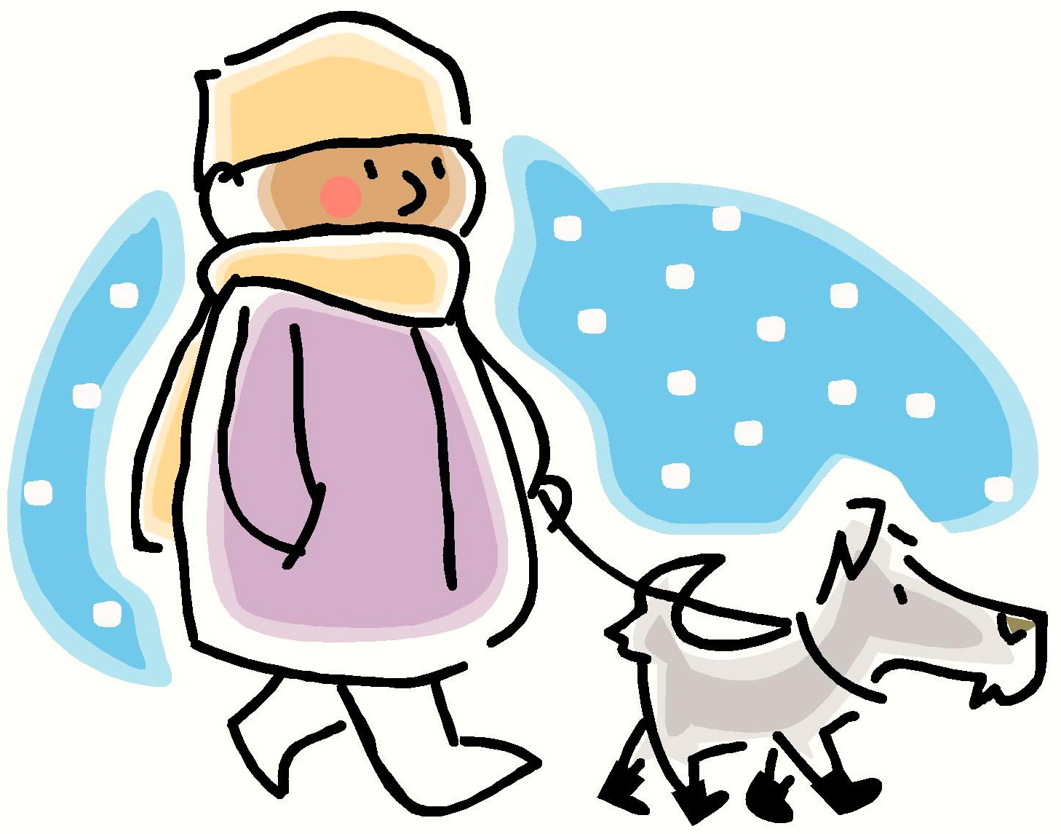
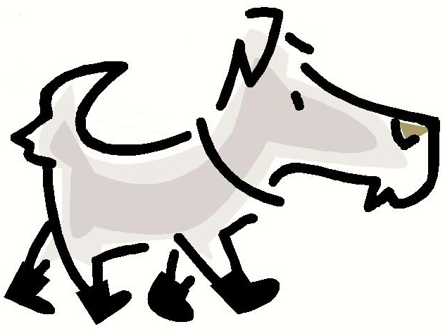
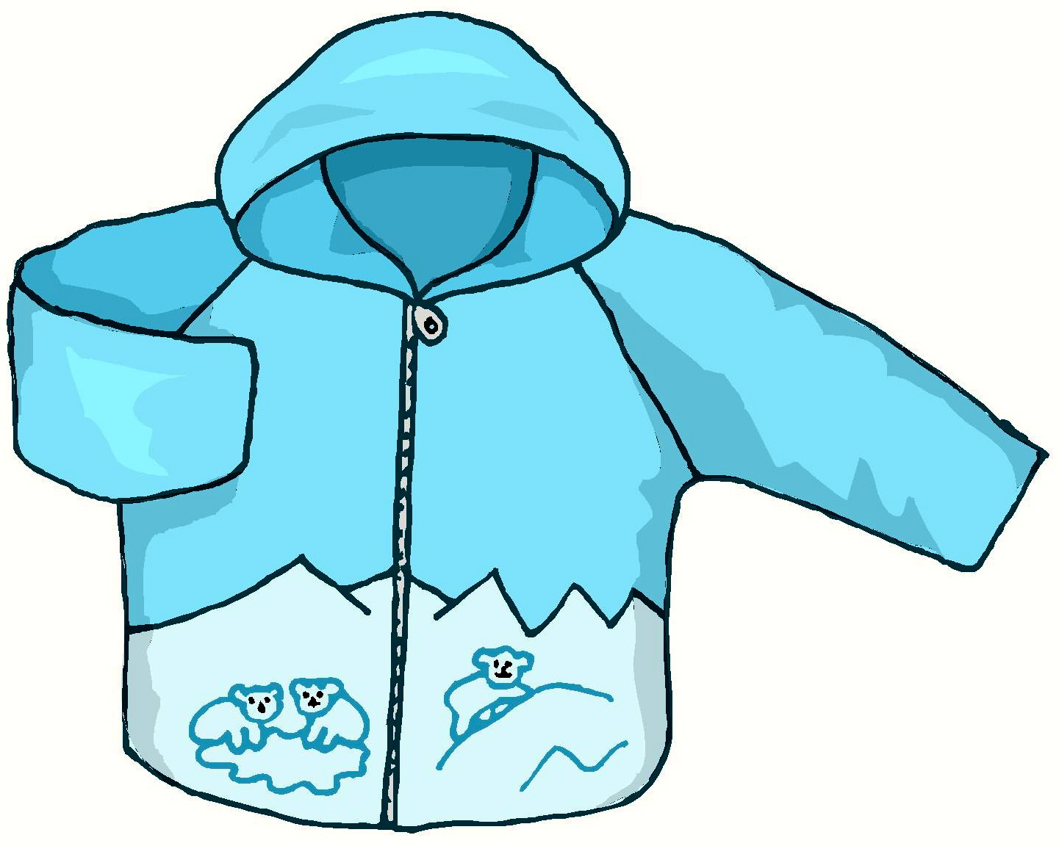
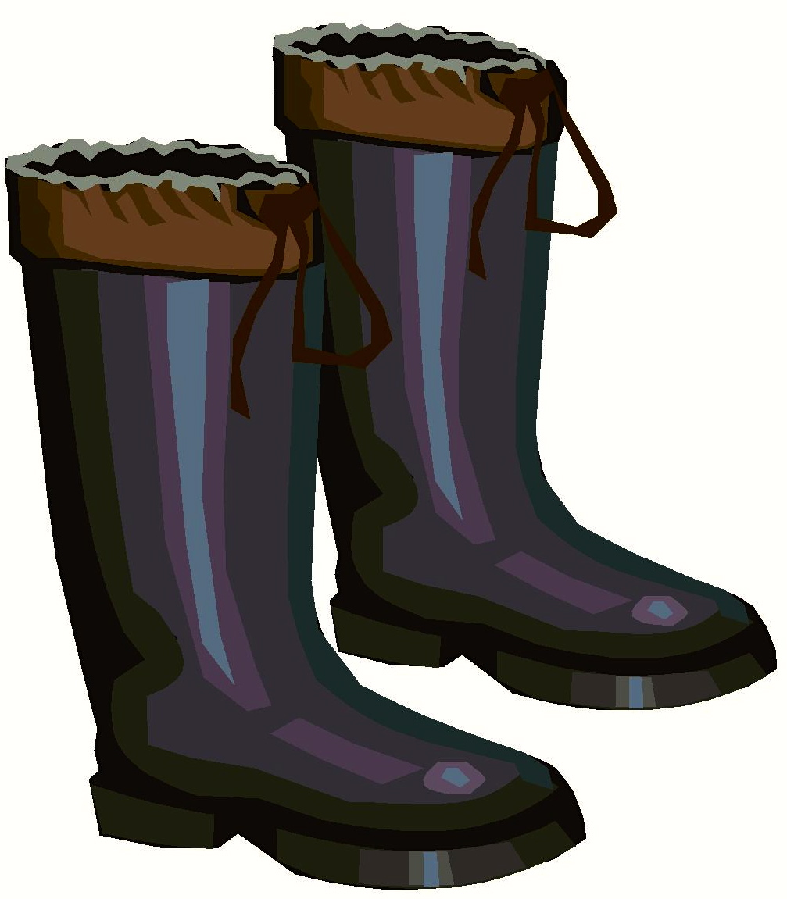

The Man Had 1 Dog
The man had 1 dog.
The man had 1 hat.
The man had 1 coat.
The dog had 4 boots.
Story level 11. More free stories and ebooks available at www.clarkness.com and www.readinghawk.com.
Text Copyright © 2014 by Clark Ness. Images from Microsoft Office Images unless otherwise noted. Permission is granted for printing, photocopying, emailing, recording, storing in a retrieval system, and transmitting this ebook in any form, or by any means, mechanical and/or electronic. Sale of this ebook and/or uploading to a commercial bookstore or commercial website is strictly forbidden without prior written permission.

