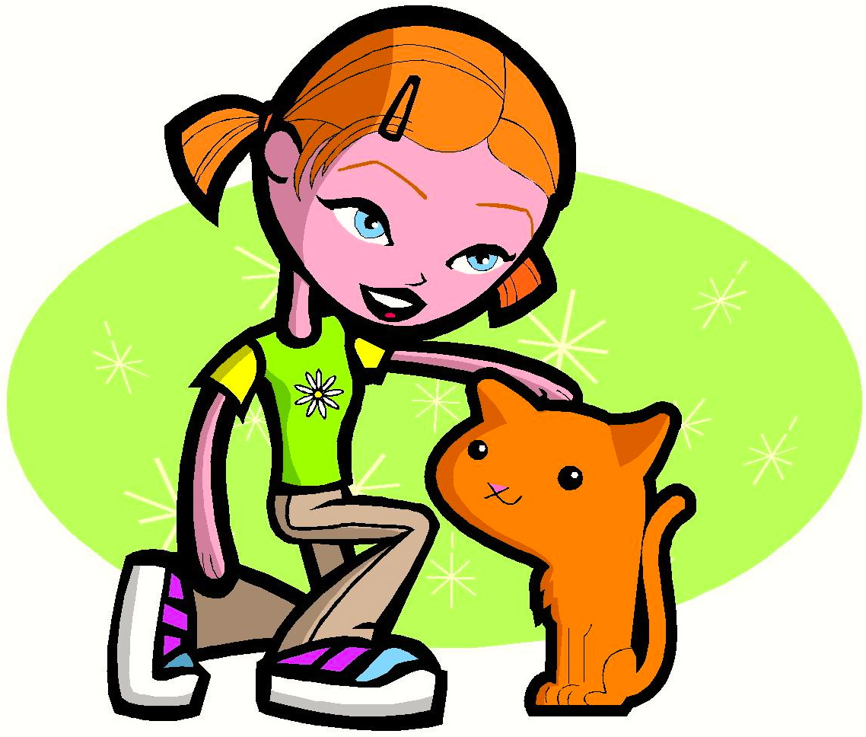
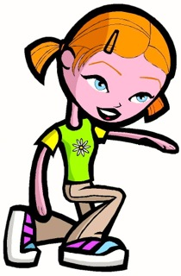
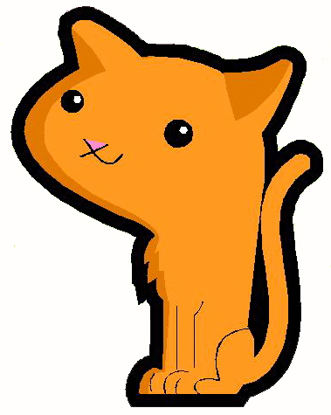

The Girl Sees the Cat

The girl sees the cat.

The cat sees the girl.

“I see the cat,” said the girl.

“The cat sees me,” said the girl.
Story level 6. More free stories and ebooks available at www.clarkness.com and www.readinghawk.com.
Text Copyright © 2014 by Clark Ness. Images from Microsoft Office Images unless otherwise noted. Permission is granted for printing, photocopying, emailing, recording, storing in a retrieval system, and transmitting this ebook in any form, or by any means, mechanical and/or electronic. Sale of this ebook and/or uploading to a commercial bookstore or commercial website is strictly forbidden without prior written permission.

