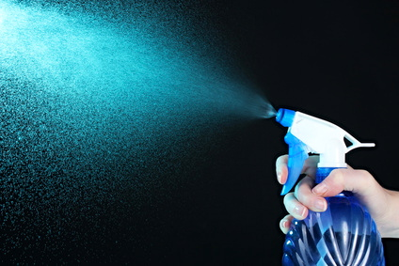
That’s Mist
“That’s mist,” said Tim.
“I see the mist,” said Dee.
“See the mist?” said Dee.
“I see the mist,” said Ann.
“That’s mist,” said Ann.
Story level 10. More free stories and ebooks available at www.clarkness.com and www.readinghawk.com.
Text Copyright © 2014 by Clark Ness. Photograph © Africa Studio - Fotolia.com. Permission is granted for printing, photocopying, emailing, recording, storing in a retrieval system, and transmitting this ebook in any form, or by any means, mechanical and/or electronic. Sale of this ebook and/or uploading to a commercial bookstore or commercial website is strictly forbidden without prior written permission.

