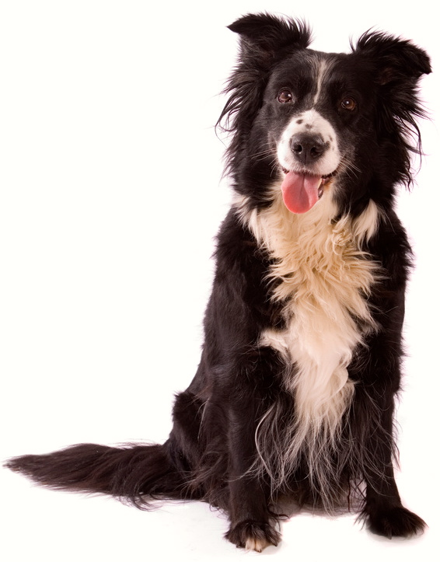
That’s Dan
“That’s Dan the dog,” said Sam.
“Dan sits,” said Tim.
“Dan sits and sits,” said Sam.
“I see Dan sit and sit,” said Tim.
Story level 10. More free stories and ebooks available at www.clarkness.com and www.readinghawk.com.
Text Copyright © 2014 by Clark Ness. Images from Microsoft Office Images unless otherwise noted. Permission is granted for printing, photocopying, emailing, recording, storing in a retrieval system, and transmitting this ebook in any form, or by any means, mechanical and/or electronic. Sale of this ebook and/or uploading to a commercial bookstore or commercial website is strictly forbidden without prior written permission.

