
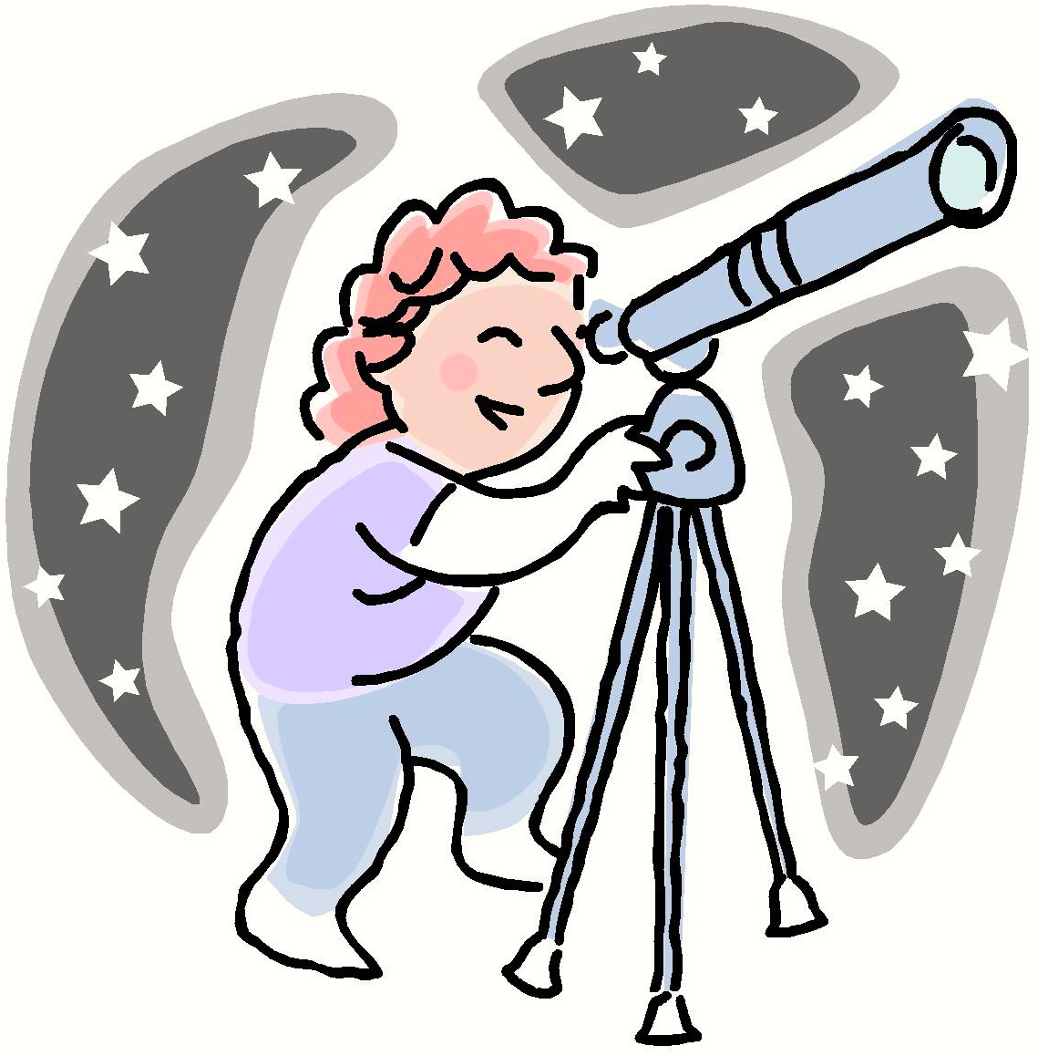

Shar Is Happy
Shar is happy. She can thank the stars that she is happy.
She wants to thank the stars that she is happy.
Story level 18. More free stories and ebooks available at www.clarkness.com and www.readinghawk.com.
Text Copyright © 2014 by Clark Ness. Images from Microsoft Office Images unless otherwise noted. Permission is granted for printing, photocopying, emailing, recording, storing in a retrieval system, and transmitting this story in any form, or by any means, mechanical and/or electronic. Sale of this story and/or uploading it to a commercial bookstore or commercial website is strictly forbidden without prior written permission.

