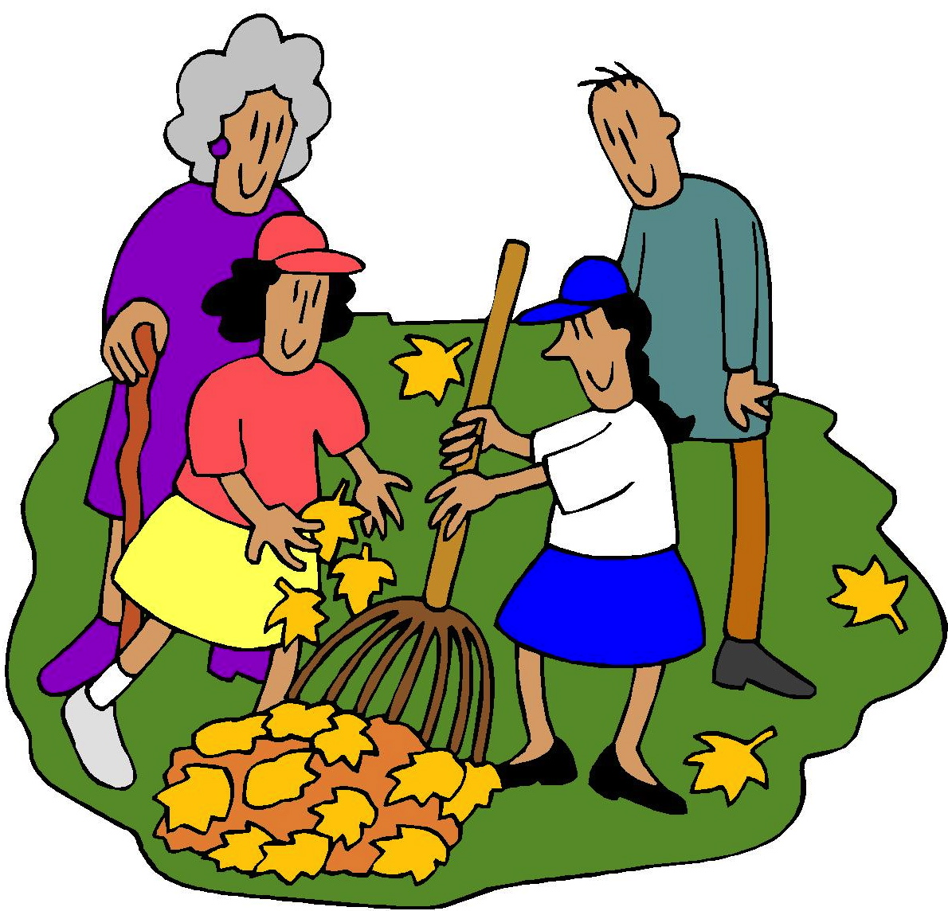
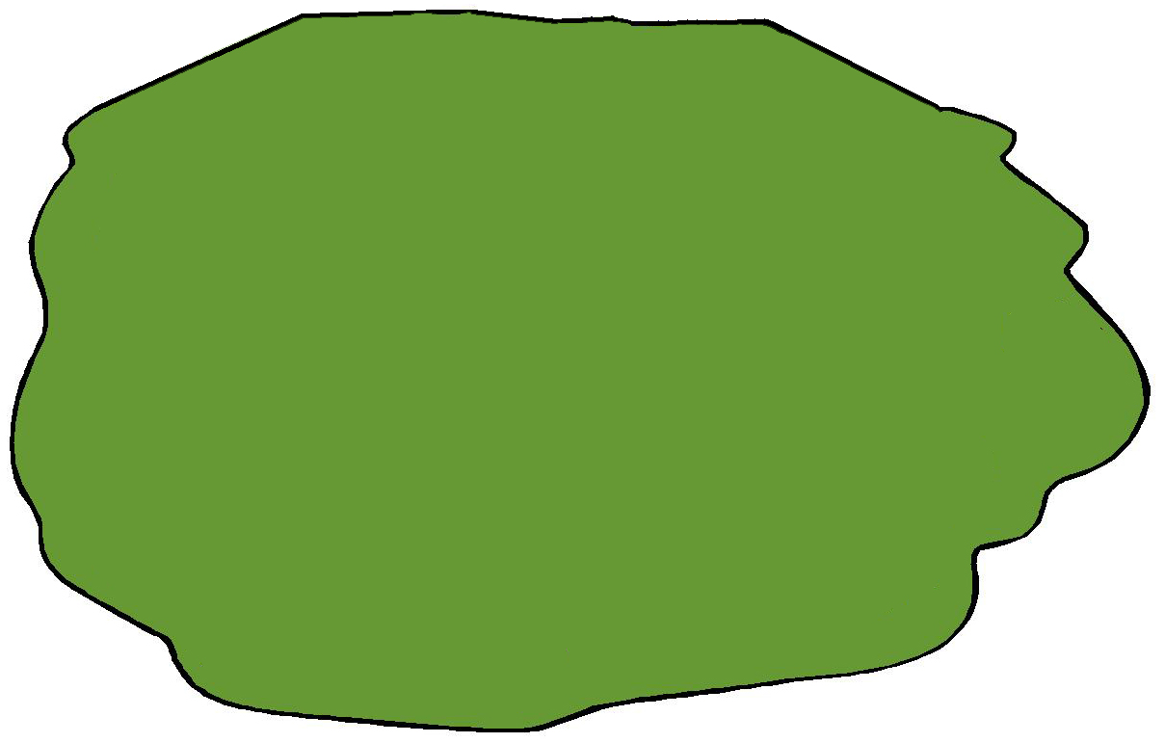
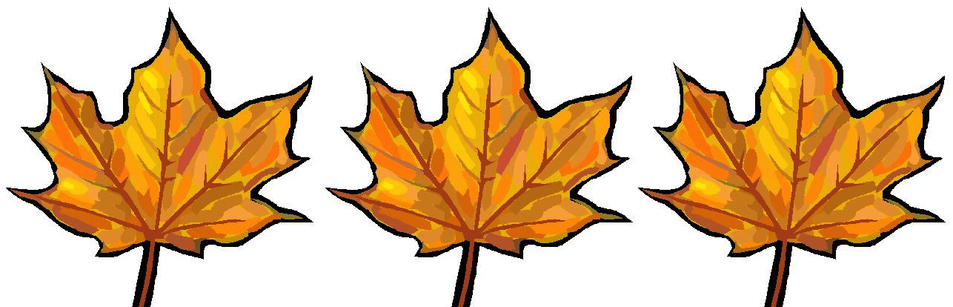
√

Rid the Lawn
“We can rid the lawn of leaves,” said Nan and Nat.
“It is neat that Nan and Nat can rid the lawn of leaves,” said Tim.
“It is sweet that Nan and Nat can rid the lawn of leaves,” said Tam.
Story level 13. More free stories and ebooks available at www.clarkness.com and www.readinghawk.com.
Text Copyright © 2014 by Clark Ness. Images from Microsoft Office Images unless otherwise noted. Permission is granted for printing, photocopying, emailing, recording, storing in a retrieval system, and transmitting this story in any form, or by any means, mechanical and/or electronic. Sale of this story and/or uploading it to a commercial bookstore or commercial website is strictly forbidden without prior written permission.

