

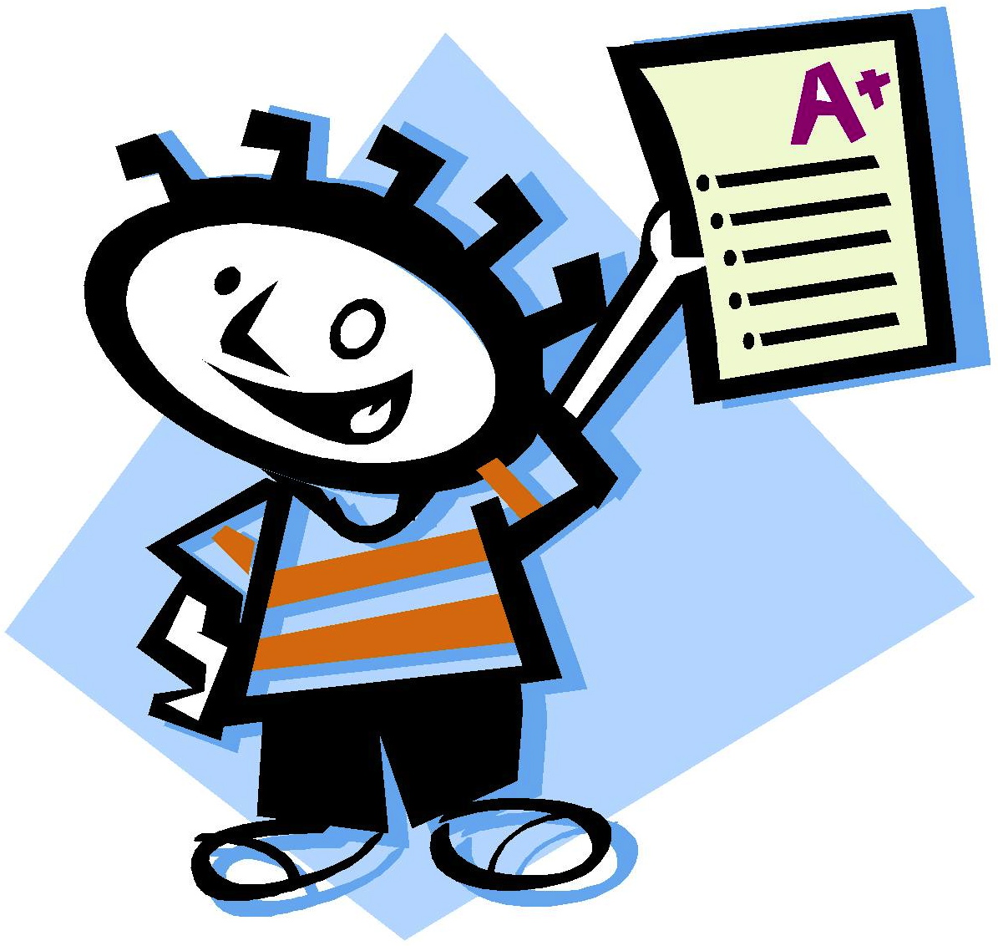

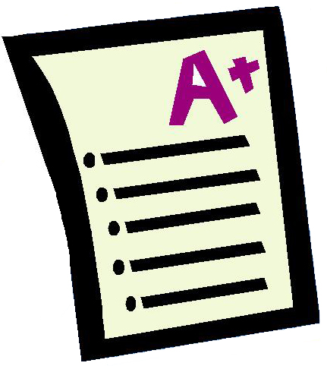
Mark Has a Neat Paper
Mark has a neat paper.
His paper could go up with a tack.
He wants it up with a tack.
Kids could see his paper that is up with a tack.
Story level 17. More free stories and ebooks available at www.clarkness.com and www.readinghawk.com.
Text Copyright © 2014 by Clark Ness. Images from Microsoft Office Images unless otherwise noted. Permission is granted for printing, photocopying, emailing, recording, storing in a retrieval system, and transmitting this story in any form, or by any means, mechanical and/or electronic. Sale of this story and/or uploading it to a commercial bookstore or commercial website is strictly forbidden without prior written permission.
A+

