
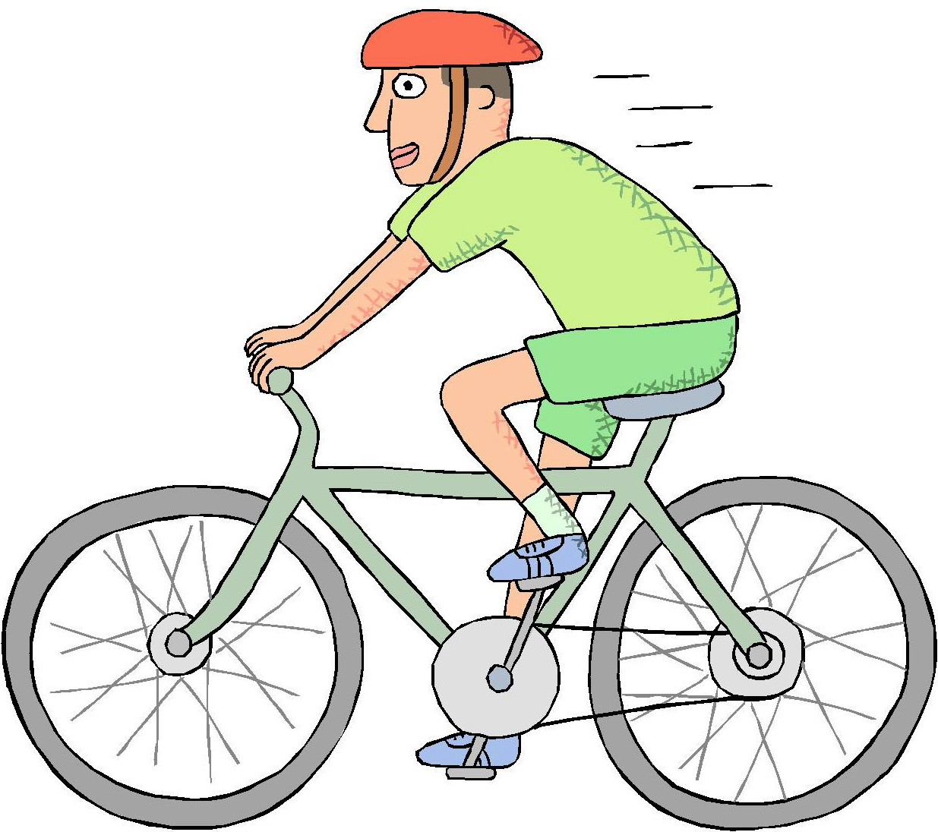
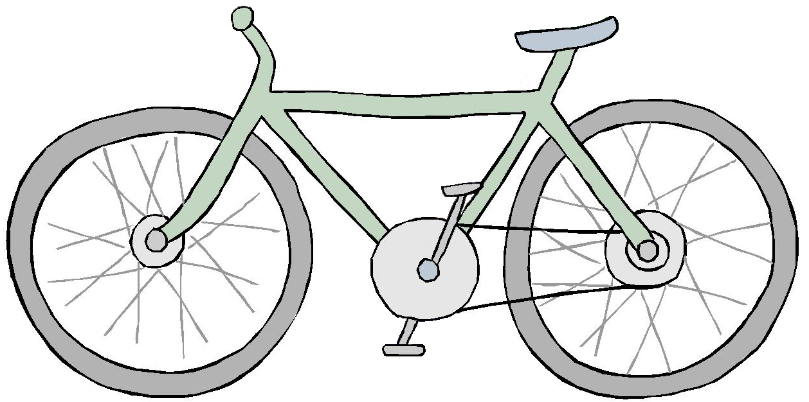

Kris and His Bicycle
Whoosh! That is Kris and his bicycle.
Whoosh! Kris and his bicycle can go.
It is neat to hear Kris and his bicycle go whoosh.
Story level 18. More free stories and ebooks available at www.clarkness.com and www.readinghawk.com.
Text Copyright © 2014 by Clark Ness. Images from Microsoft Office Images unless otherwise noted. Permission is granted for printing, photocopying, emailing, recording, storing in a retrieval system, and transmitting this story in any form, or by any means, mechanical and/or electronic. Sale of this story and/or uploading it to a commercial bookstore or commercial website is strictly forbidden without prior written permission.

