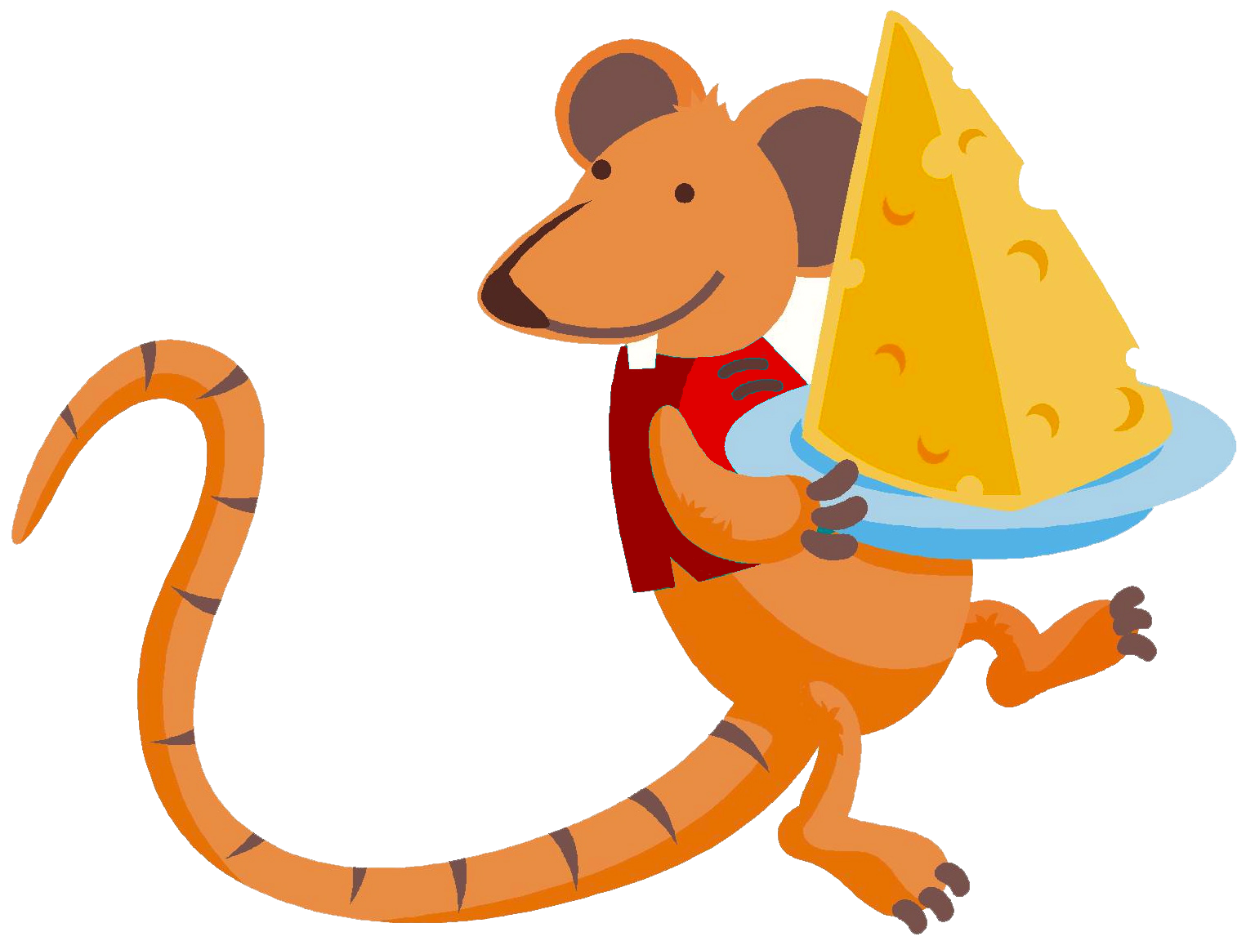
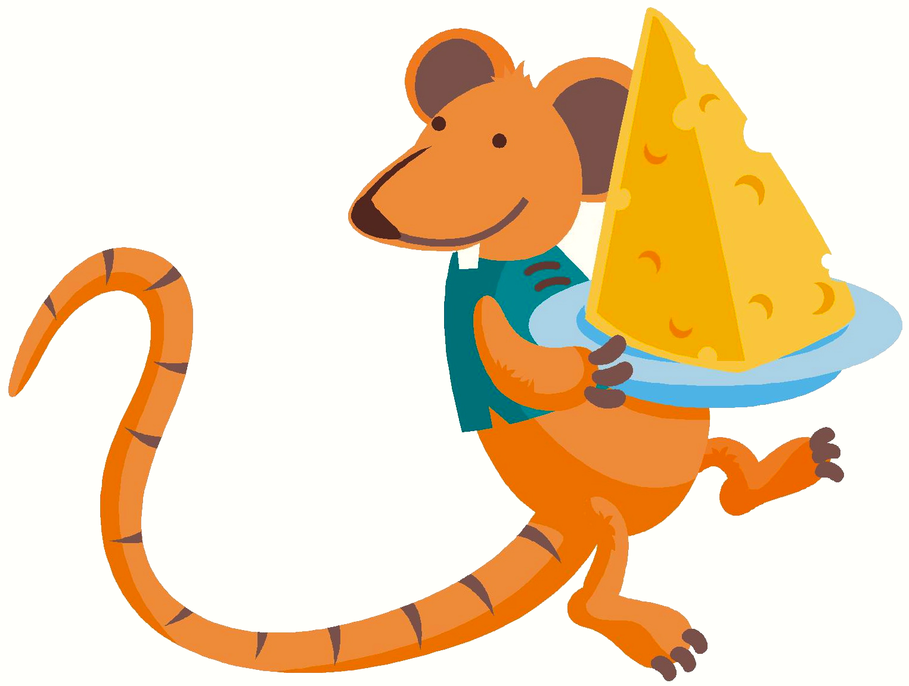
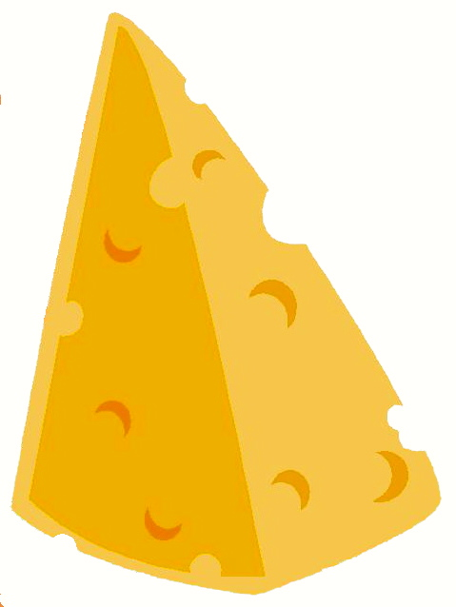

Is a Rat
Sid is a rat, and Tad is a rat.
Sid wants cheese, and Tad wants cheese. The rats want cheese.
The rats eat cheese.
“Cheese is a neat treat,” said Tad.
Story level 13. More free stories and ebooks available at www.clarkness.com and www.readinghawk.com.
Text Copyright © 2014 by Clark Ness. Images from Microsoft Office Images unless otherwise noted. Permission is granted for printing, photocopying, emailing, recording, storing in a retrieval system, and transmitting this story in any form, or by any means, mechanical and/or electronic. Sale of this story and/or uploading it to a commercial bookstore or commercial website is strictly forbidden without prior written permission.

