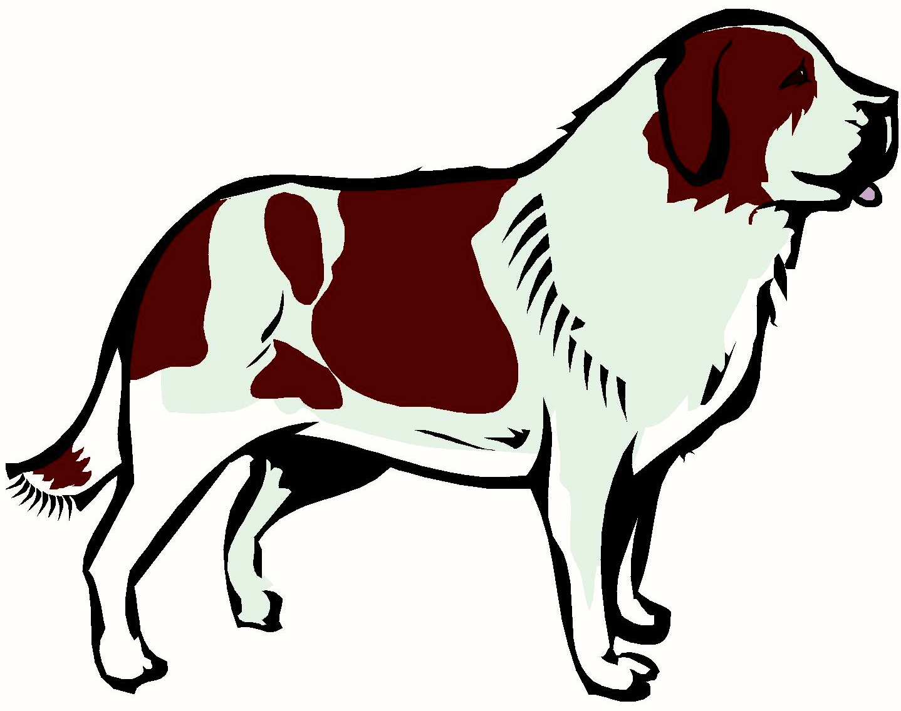
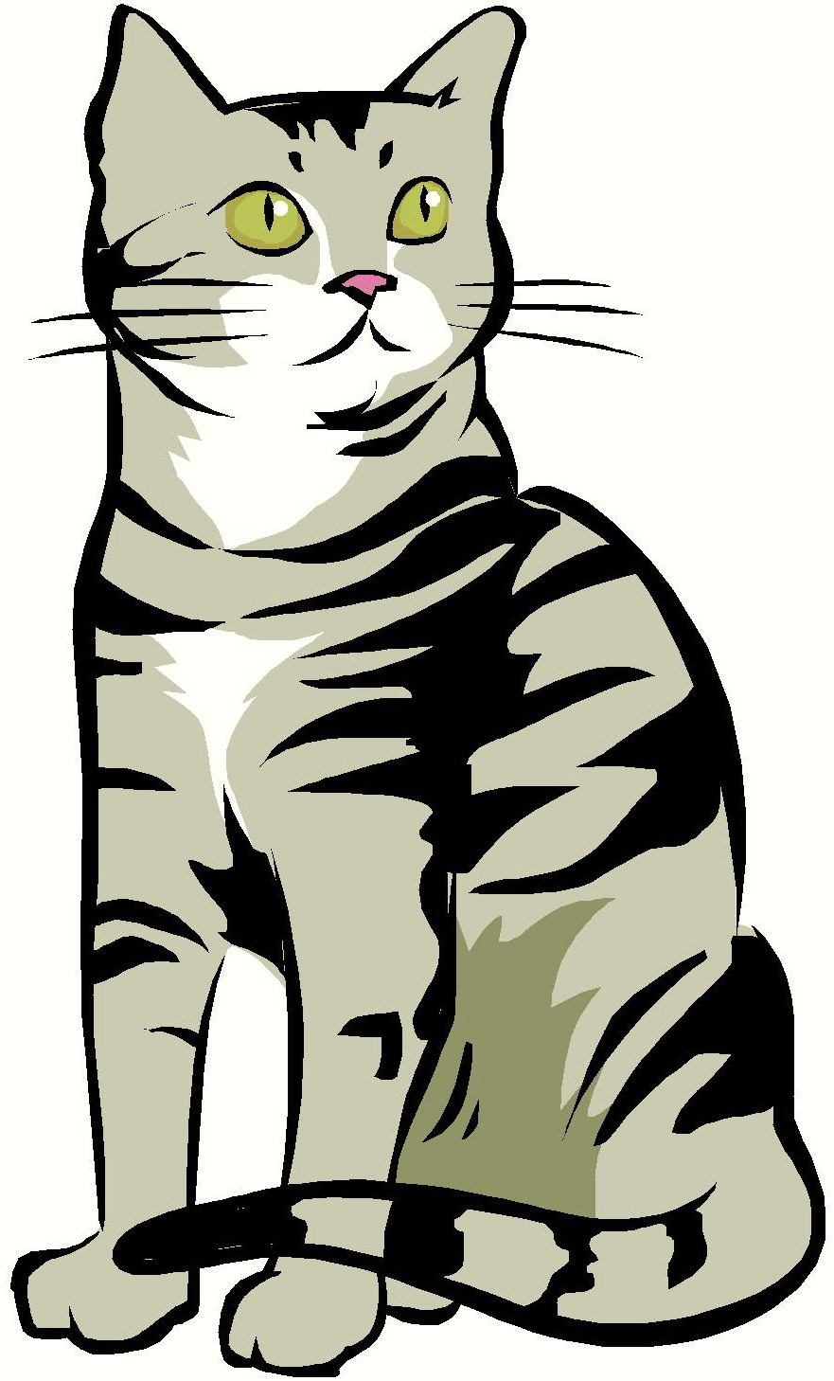
I See 2 Sams

I see Sam the dog.

I see Sam the cat.

I see 2 Sams.

2 Sams I see.

I see 2 Sams.
Story level 6. More free stories and ebooks available at www.clarkness.com and www.readinghawk.com.
Text Copyright © 2014 by Clark Ness. Images from Microsoft Office Images unless otherwise noted. Permission is granted for printing, photocopying, emailing, recording, storing in a retrieval system, and transmitting this ebook in any form, or by any means, mechanical and/or electronic. Sale of this ebook and/or uploading to a commercial bookstore or commercial website is strictly forbidden without prior written permission.
Sam
Sam

