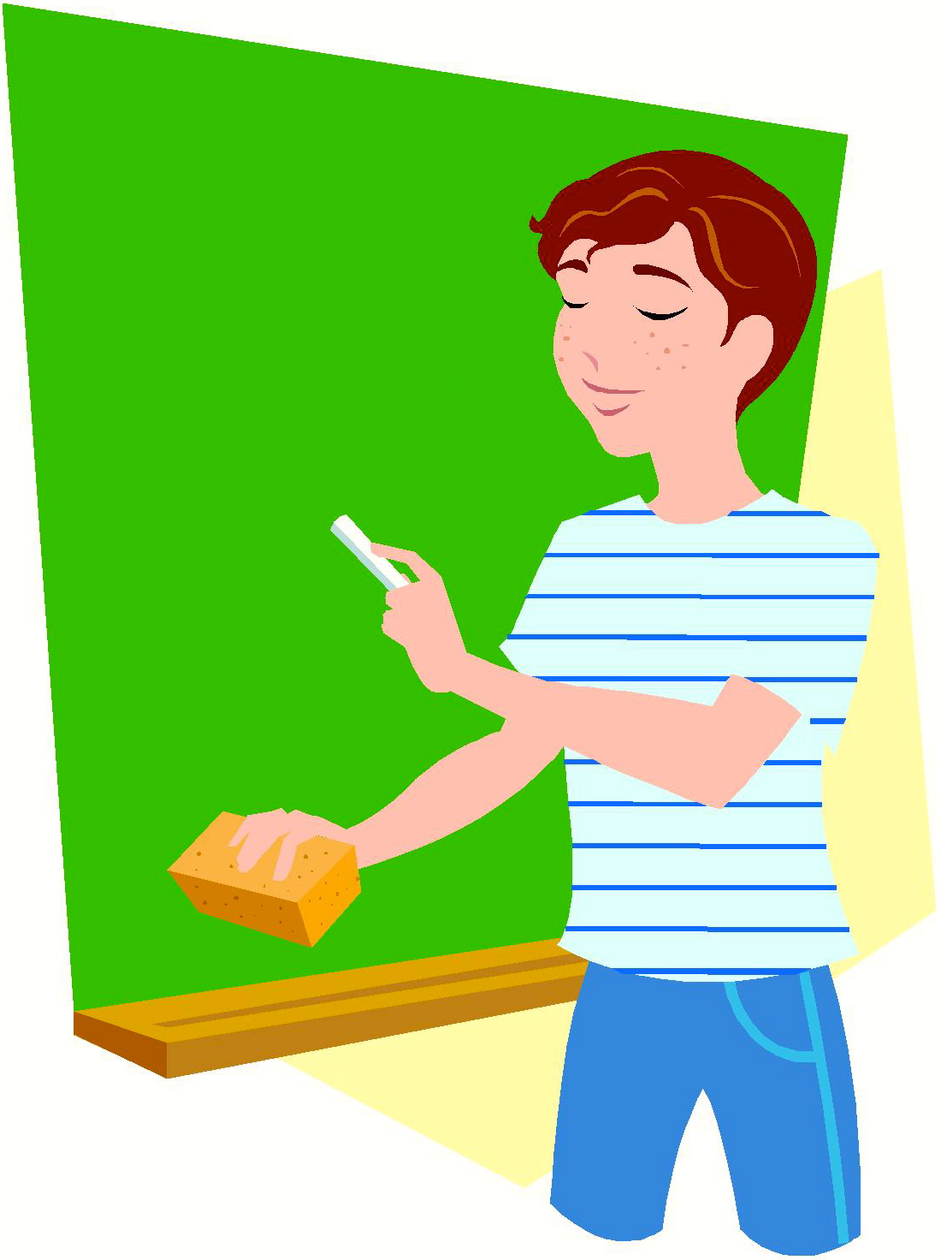
I Am Sam. I Add

See me.

I am Sam.

I add.

See me add.

I am Sam. I add.
Story level 5. More free stories and ebooks available at www.clarkness.com and www.readinghawk.com.
Text Copyright © 2014 by Clark Ness. Images from Microsoft Office Images unless otherwise noted. Permission is granted for printing, photocopying, emailing, recording, storing in a retrieval system, and transmitting this story in any form, or by any means, mechanical and/or electronic. Sale of this story and/or uploading it to a commercial bookstore or commercial website is strictly forbidden without prior written permission.
2 + 2 = 4

