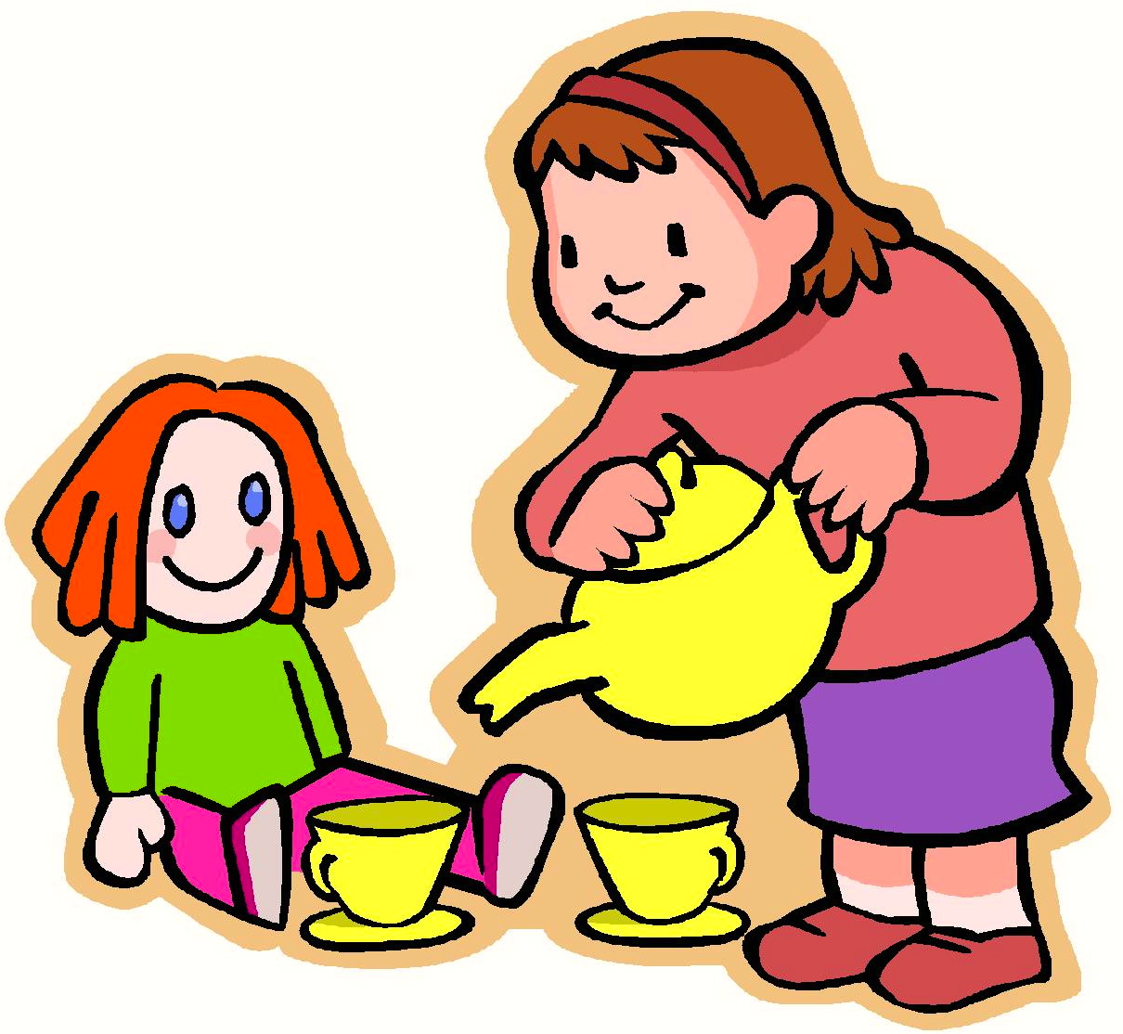
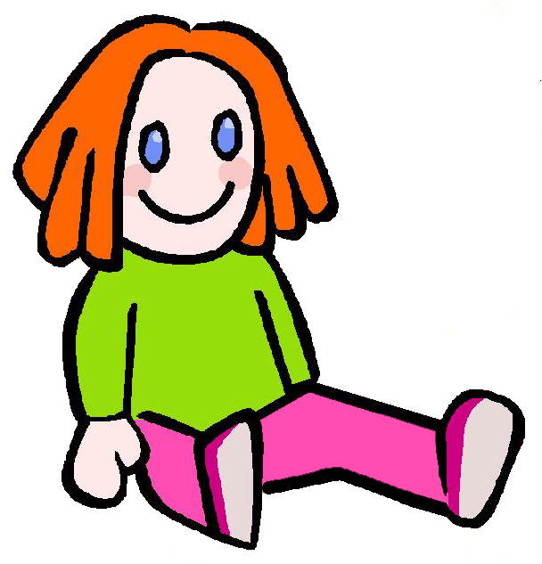

Drank Tea
Shar and a doll had tea.
Shar drank the tea.
The doll didn’t drink the tea.
“It is neat that I drank tea and was with this doll,” said Shar.
Story level 18. More free stories and ebooks available at www.clarkness.com and www.readinghawk.com.
Text Copyright © 2014 by Clark Ness. Images from Microsoft Office Images unless otherwise noted. Permission is granted for printing, photocopying, emailing, recording, storing in a retrieval system, and transmitting this story in any form, or by any means, mechanical and/or electronic. Sale of this story and/or uploading it to a commercial bookstore or commercial website is strictly forbidden without prior written permission.

