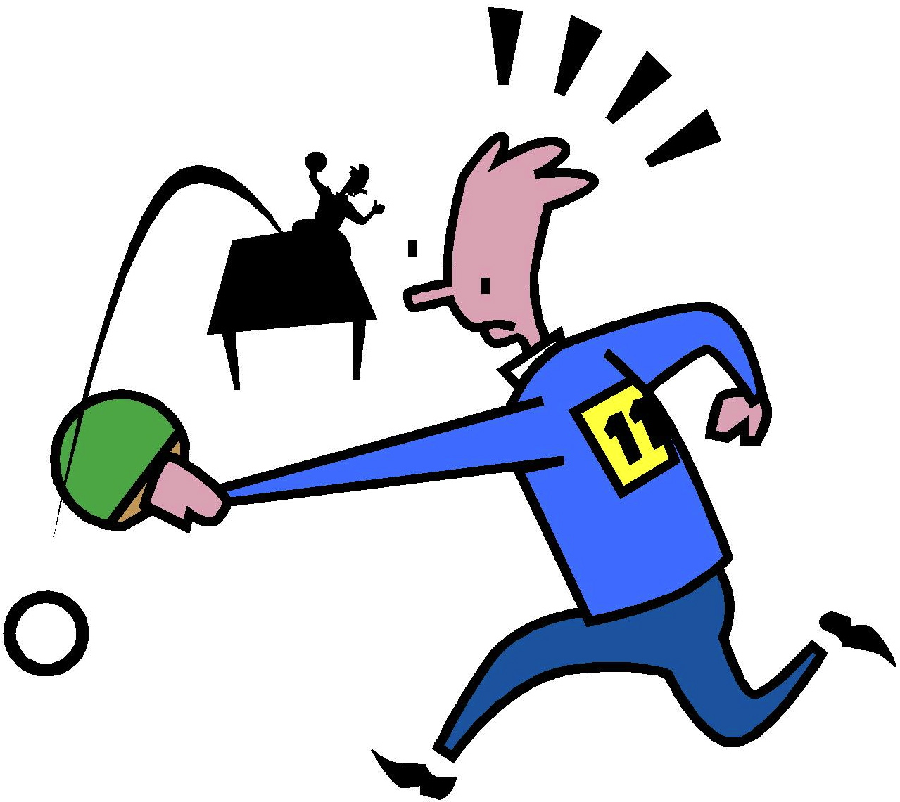
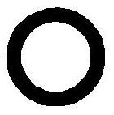

Couldn’t Hit the Ball
The man sees the ball.
Swish. The man couldn’t hit the ball.
The man is sad that he couldn’t hit the ball.
Story level 15. More free stories and ebooks available at www.clarkness.com and www.readinghawk.com.
Text Copyright © 2014 by Clark Ness. Images from Microsoft Office Images unless otherwise noted. Permission is granted for printing, photocopying, emailing, recording, storing in a retrieval system, and transmitting this story in any form, or by any means, mechanical and/or electronic. Sale of this story and/or uploading it to a commercial bookstore or commercial website is strictly forbidden without prior written permission.

