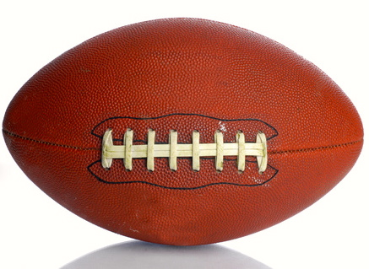
Football
By Clark Ness

Visit www.clarkness.com and www.readinghawk.com
for free ebooks and stories.

Reading Level: Lexile® Measure 610L
Flesch-Kincaid Grade Level 3.7

Nonfiction
A football is a funny-shaped ball.
1
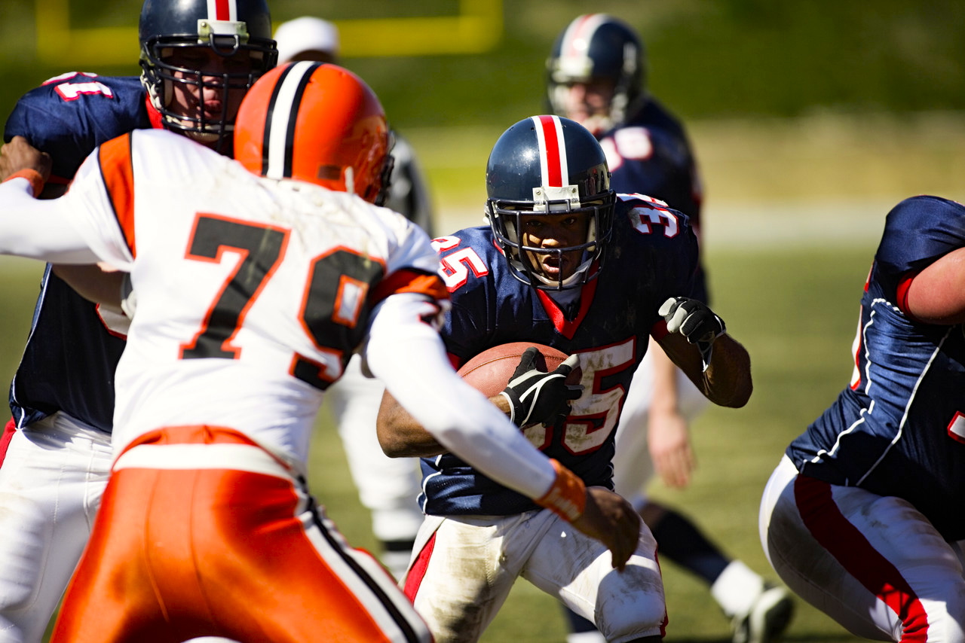
Players use a football to play an exciting game called football.
2

In football, a player can run with a football.
3
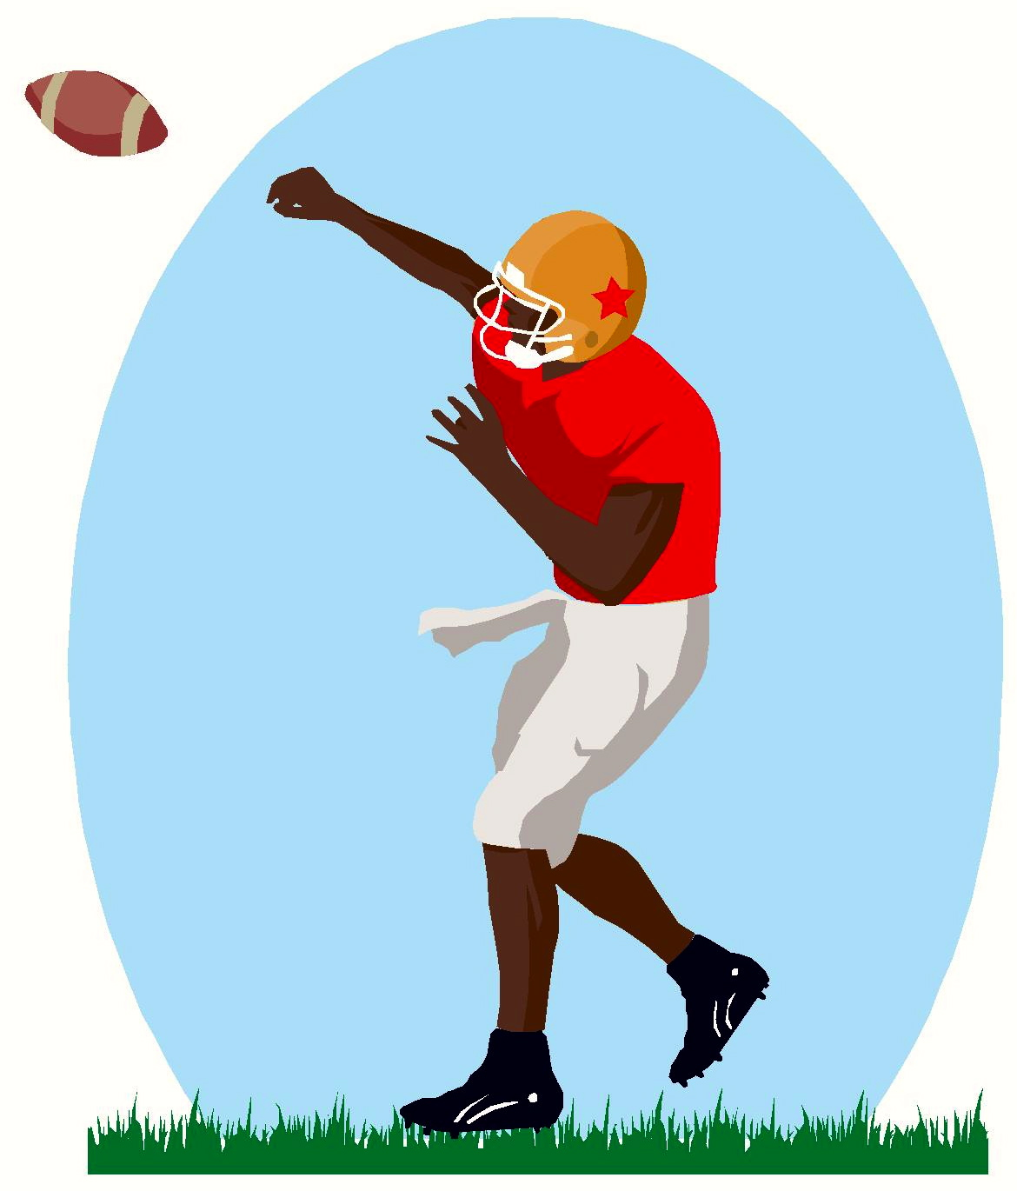
In football, a player can pass a football.
4
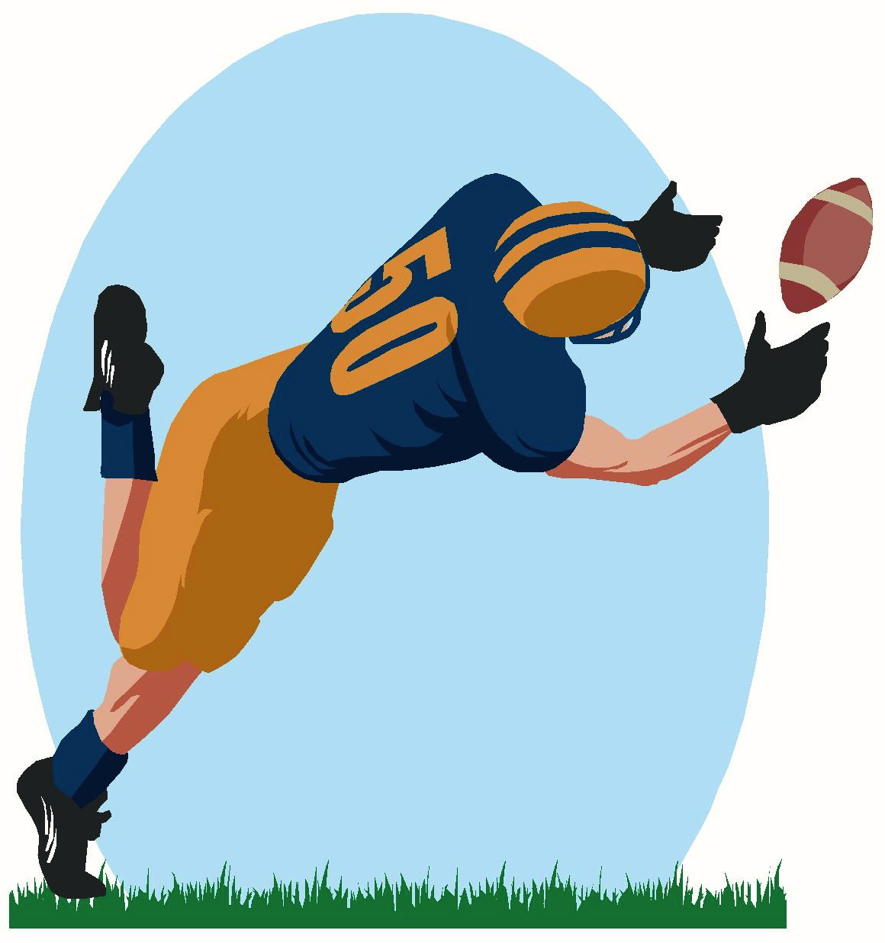
javascript:void(0)
In football, a player can catch a football.
5
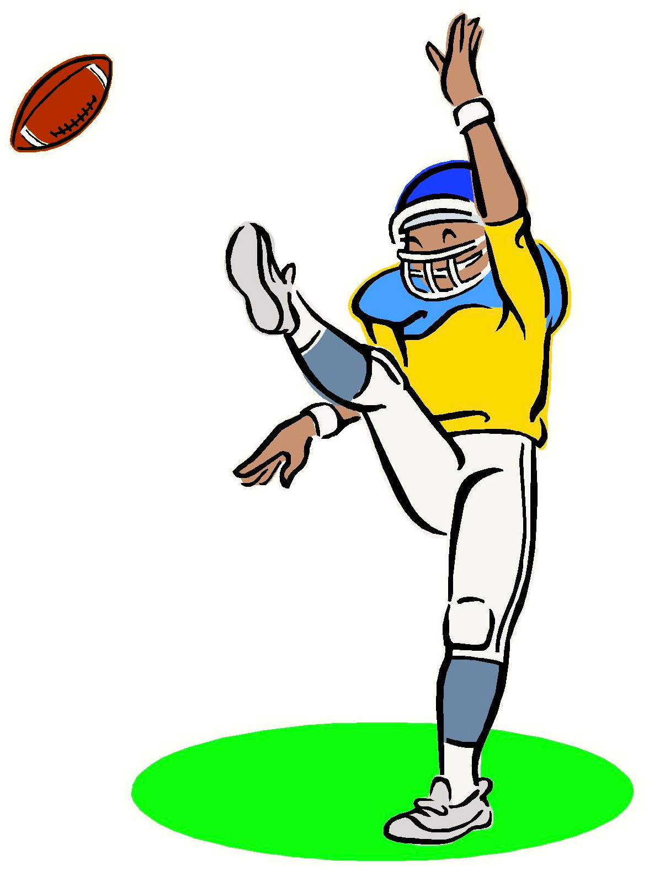
In football, a player can kick a football.
6
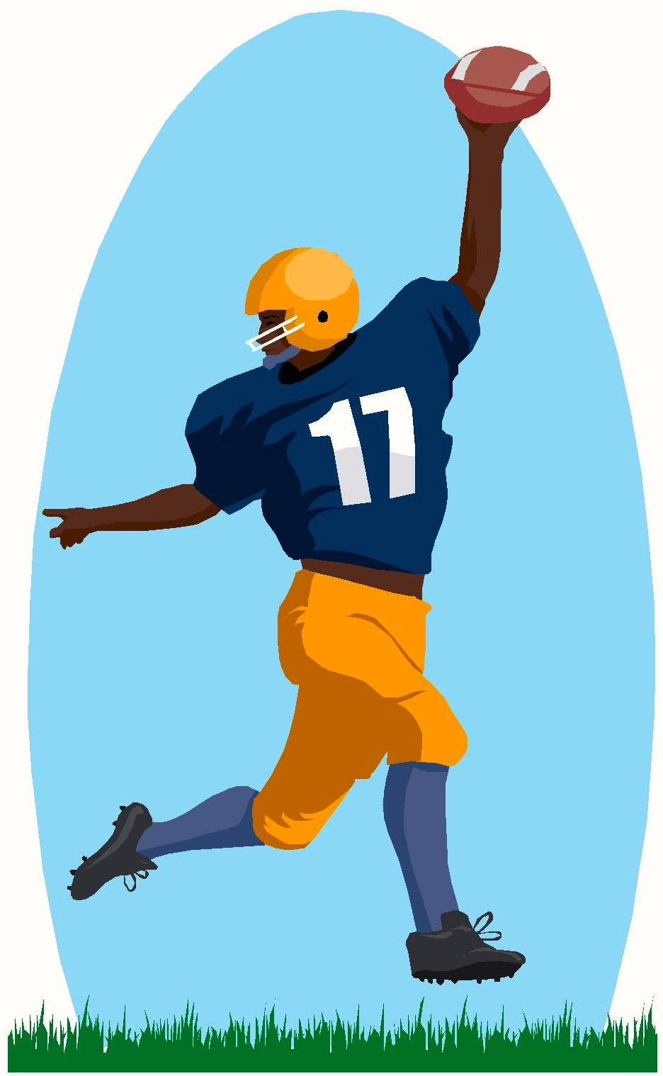
In football, points are scored when the football crosses the goal line.
7
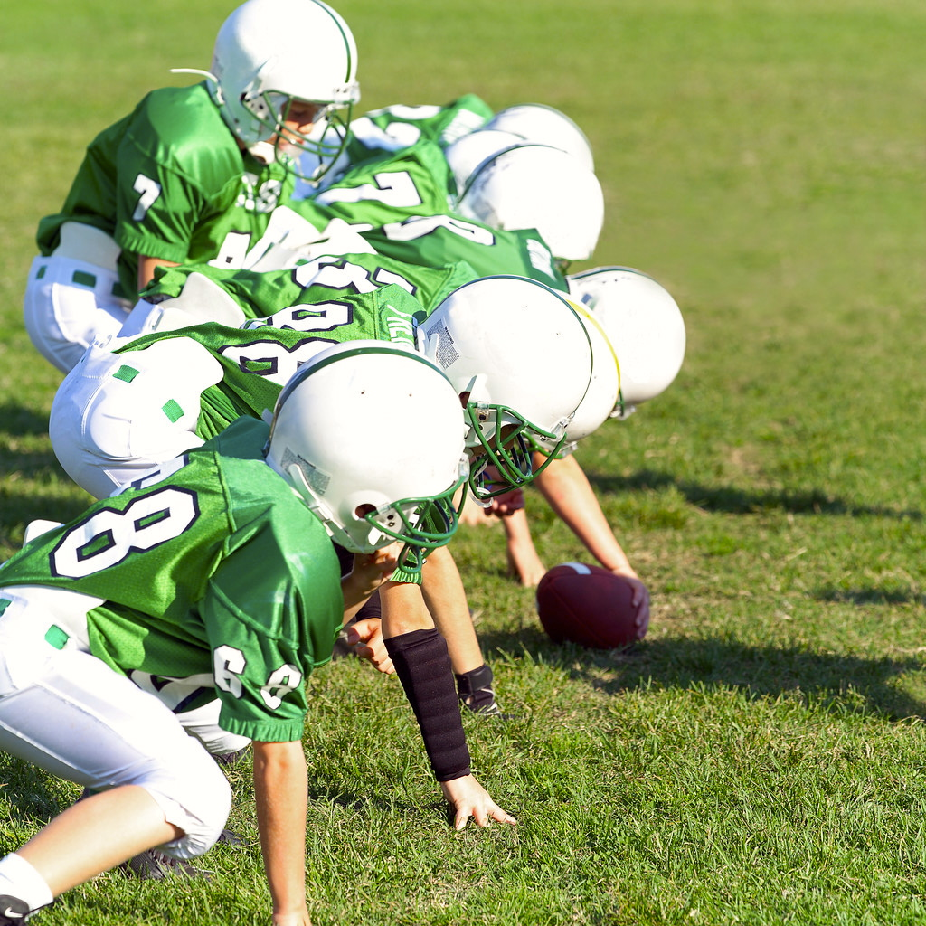
Football is a fun game to play, and it is played with a football.
More free ebooks and stories are available at www.clarkness.com and www.readinghawk.com.
Text Copyright © 2013 by Clark Ness. Images are from Microsoft Office Images unless otherwise noted. Permission is granted for printing, photocopying, emailing, recording, storing in a retrieval system, and transmitting this story in any form, or by any means, mechanical and/or electronic. Sale of this story and/or uploading to a commercial bookstore or commercial website is strictly forbidden without prior written permission.
8

