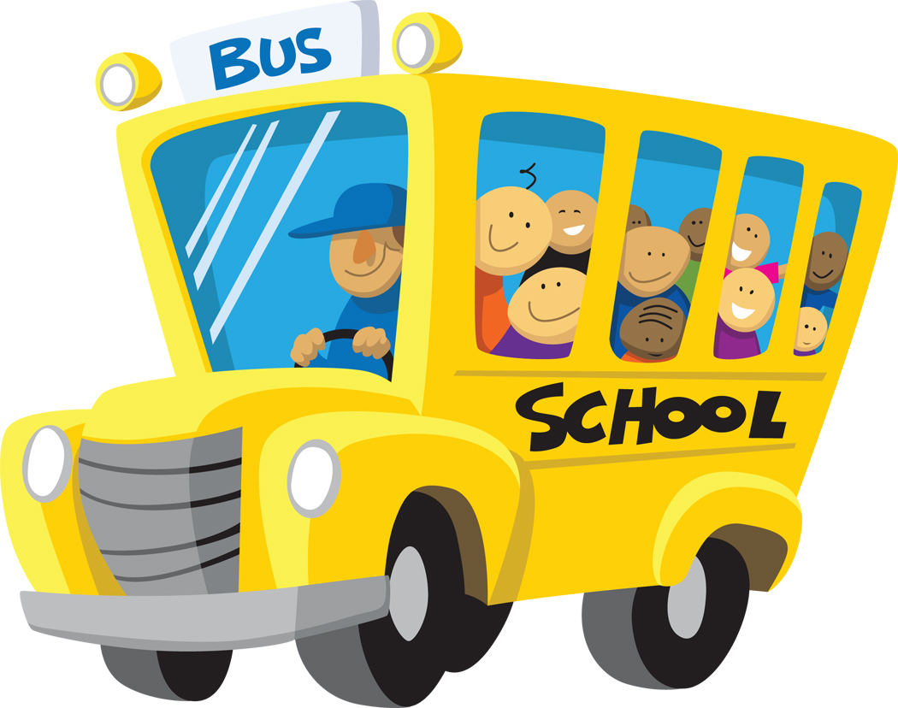
Farm Animals at School
By Clark Ness

Visit www.clarkness.com and www.readinghawk.com
for more free ebooks and stories.

Reading Level: Lexile® Measure 230L
Flesch-Kincaid Grade Level 1.0

Fiction
Some kids went to school in a bus.
1
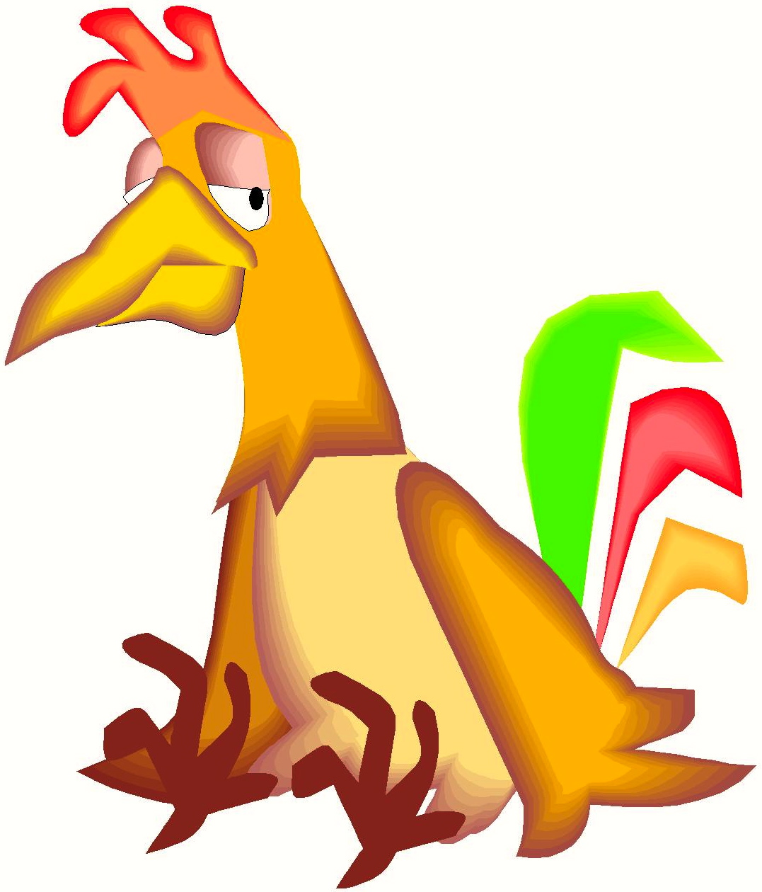
When they got to school, one teacher was a chicken.
2
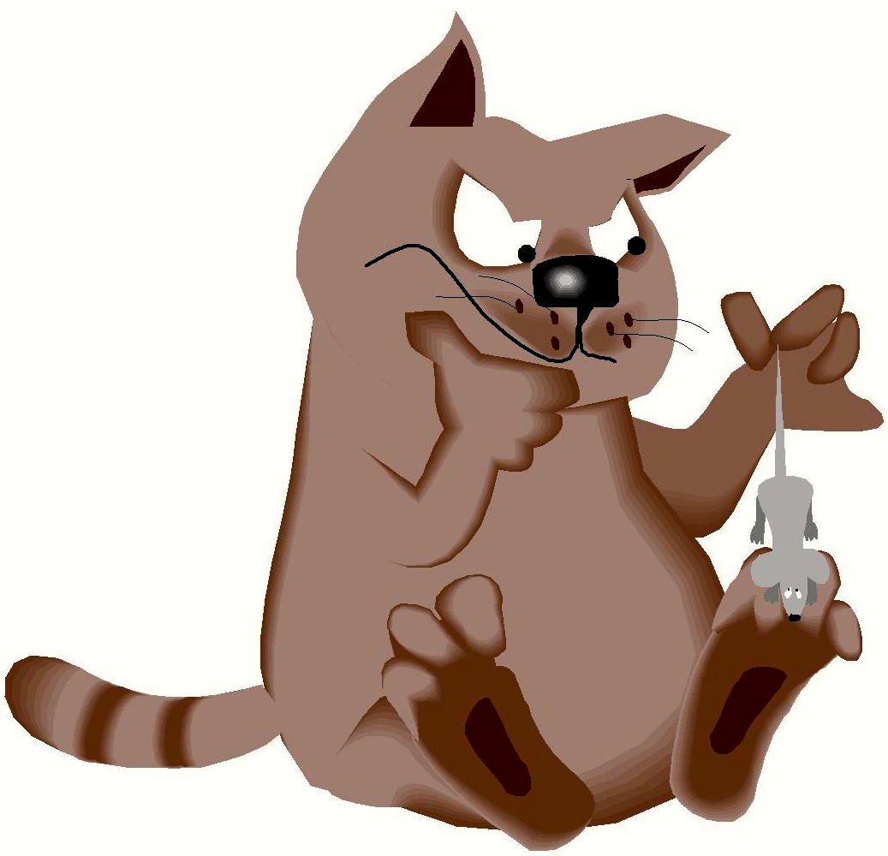
One teacher was a cat.
3
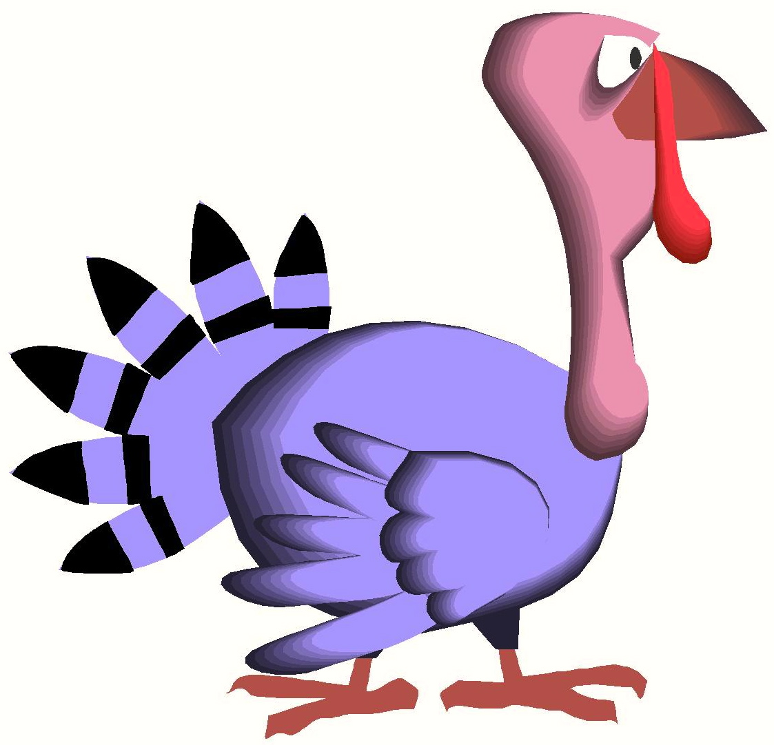
One teacher was a turkey.
4
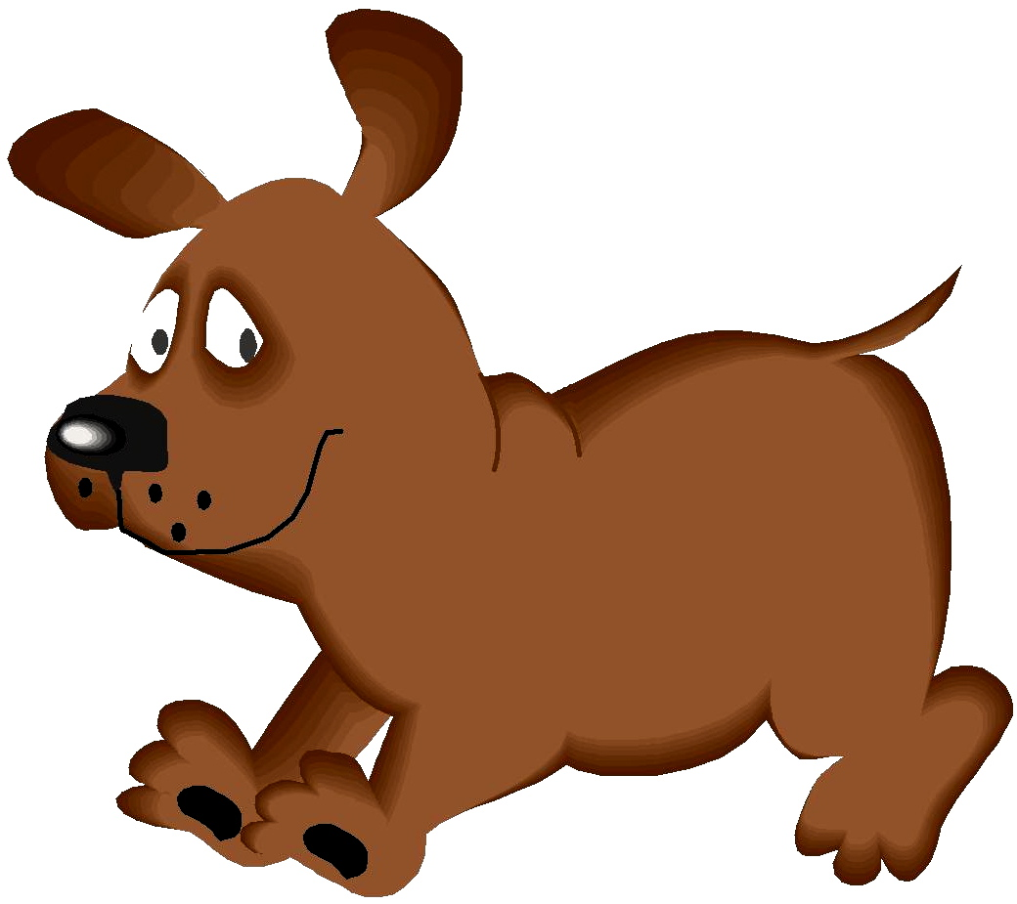
One teacher was a dog.
5
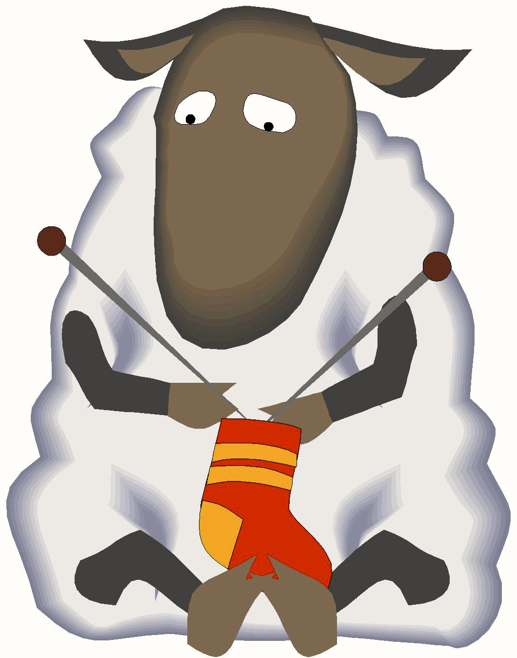
One teacher was a sheep.
6
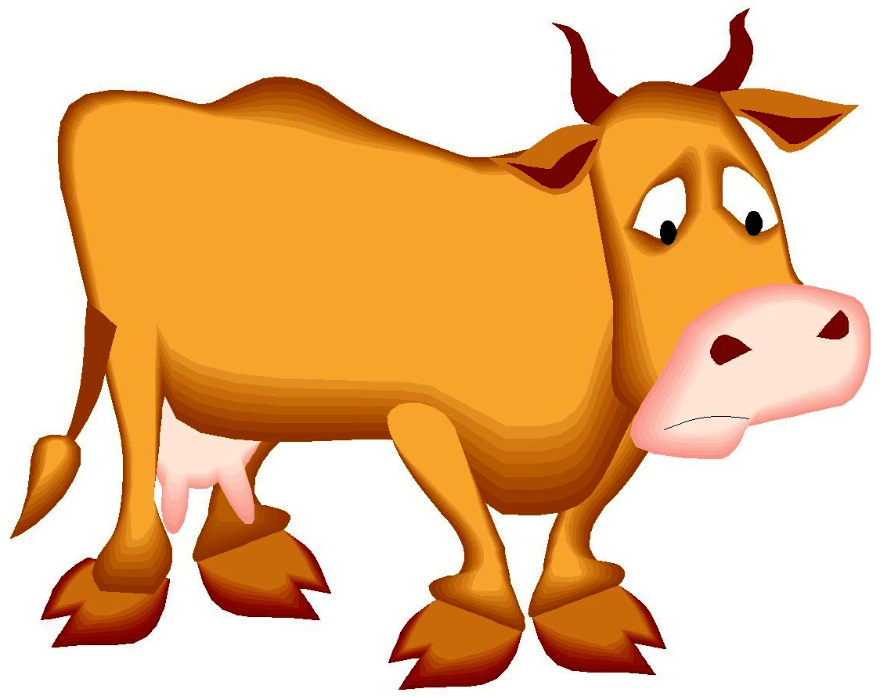
One teacher was a cow.
7
There were a lot of farm animals at school that day.
More free ebooks and stories are available at www.clarkness.com and www.readinghawk.com.
Text Copyright © 2013 by Clark Ness. Images are from Microsoft Office Images unless otherwise noted. Permission is granted for printing, photocopying, emailing, recording, storing in a retrieval system, and transmitting this story in any form, or by any means, mechanical and/or electronic. Sale of this story and/or uploading to a commercial bookstore or commercial website is strictly forbidden without prior written permission.
8

