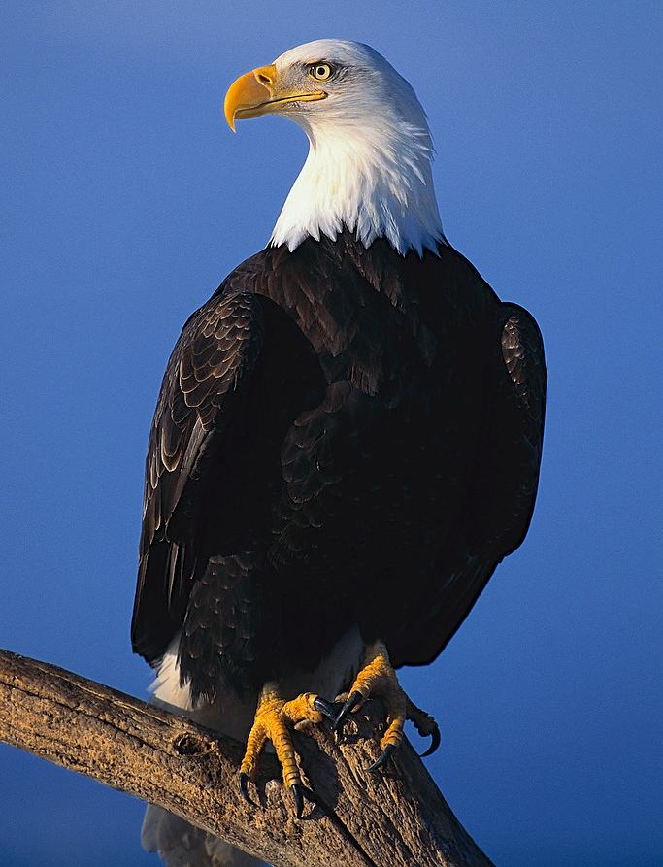
Can Fly
By Clark Ness

Visit www.clarkness.com and www.readinghawk.com
for more free ebooks and stories.

Reading Level: Lexile® Measure 0L
Flesch-Kincaid Grade Level 1.7

Nonfiction
This is an eagle.
1
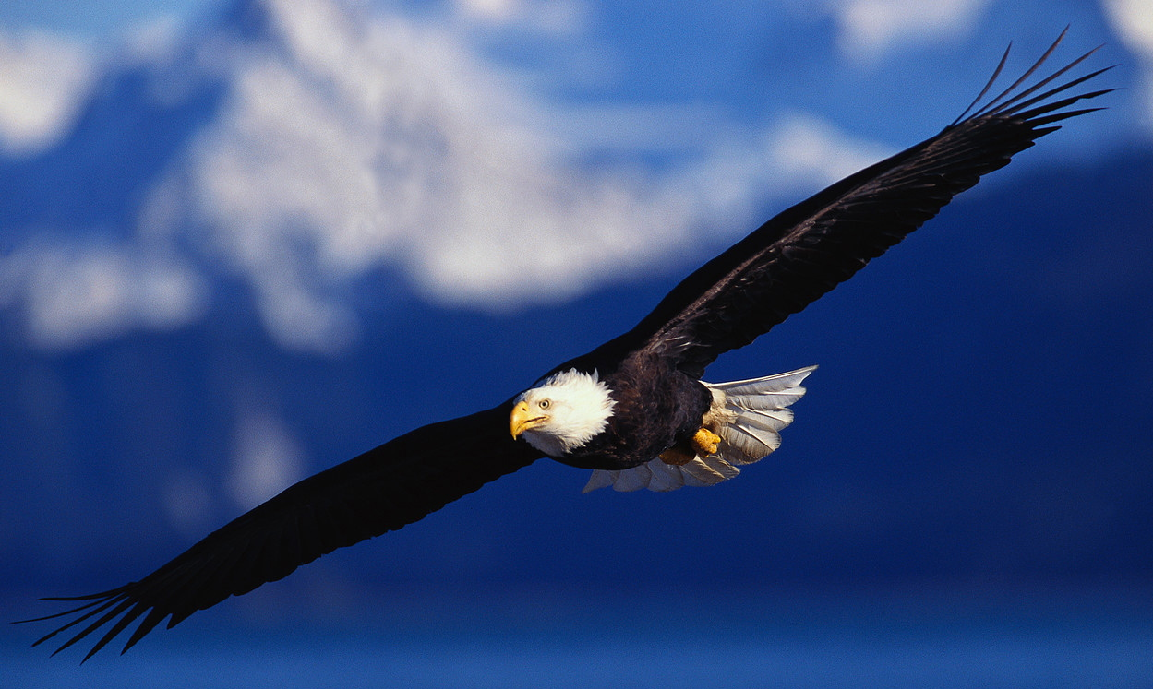
Eagles can fly.
2
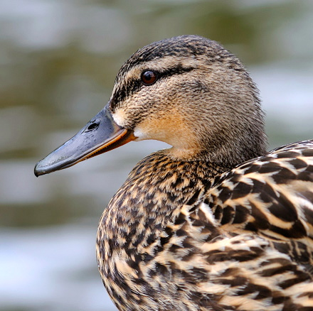
This is a duck.
3
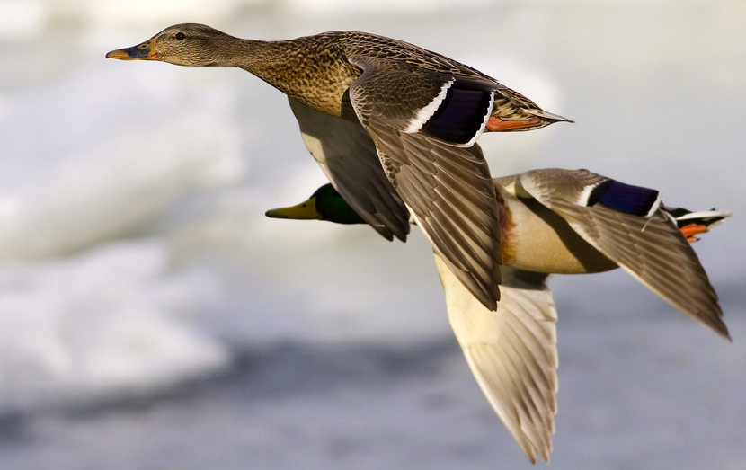
Ducks can fly.
4
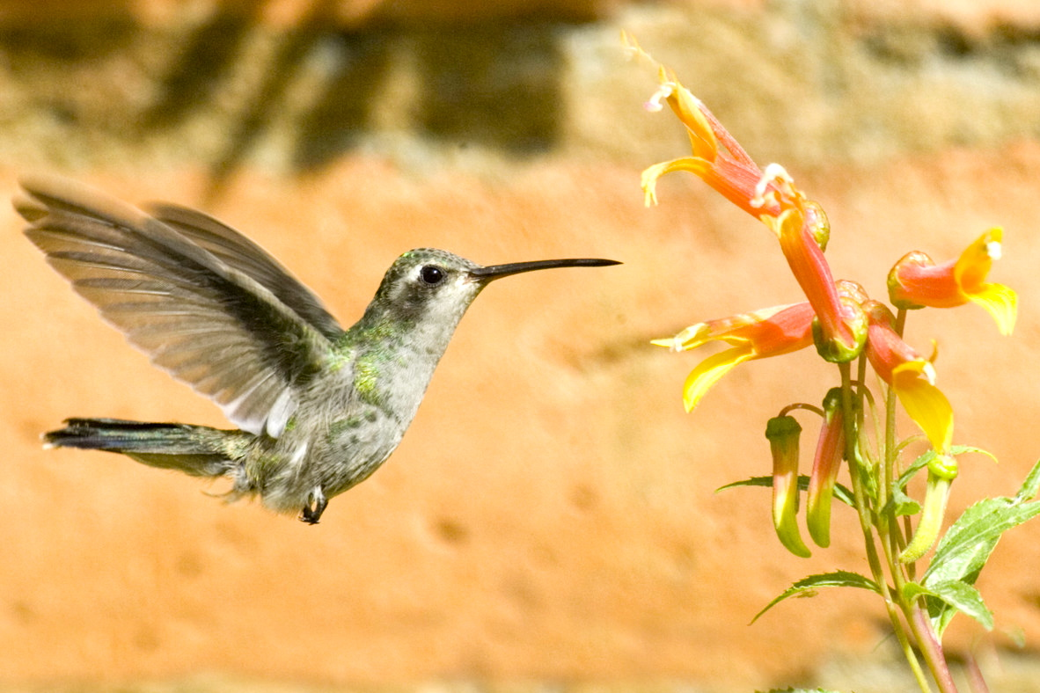
This is a hummingbird. Hummingbirds can fly.
5
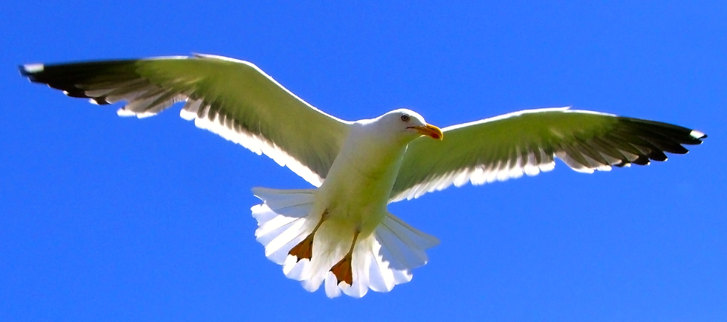
This is a seagull. Seagulls can fly.
6
Photograph © Chris Rawlings - sxc.hu
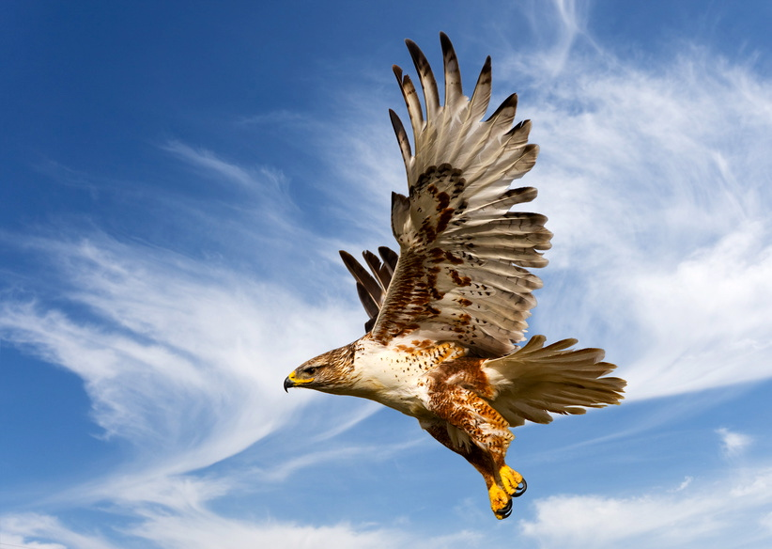
This is a hawk. Hawks can fly.
7
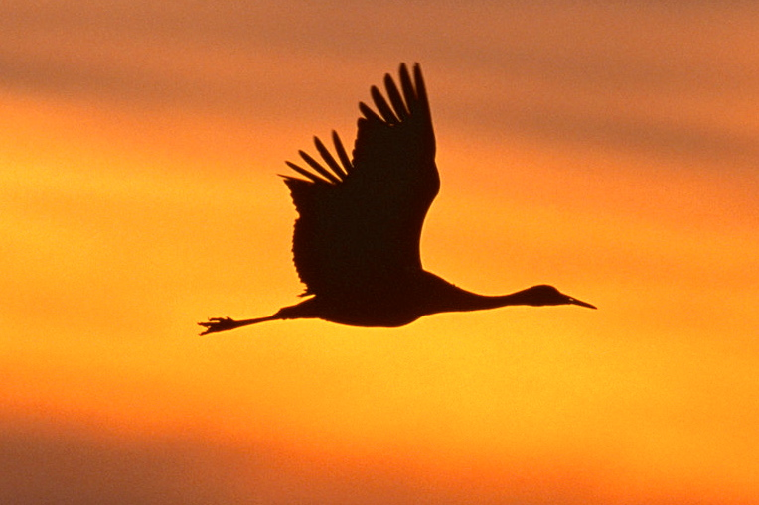
This is a crane. Cranes can fly.
8
More free ebooks and stories are available at www.clarkness.com and www.readinghawk.com.
Text Copyright © 2013 by Clark Ness. Images are from Microsoft Office Images unless otherwise noted. Permission is granted for printing, photocopying, emailing, recording, storing in a retrieval system, and transmitting this story in any form, or by any means, mechanical and/or electronic. Sale of this story and/or uploading to a commercial bookstore or commercial website is strictly forbidden without prior written permission.

