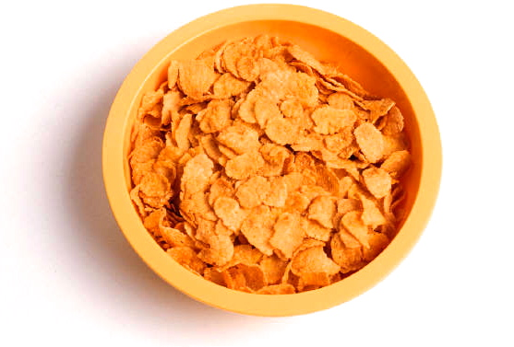
Breakfast
By Clark Ness

Visit www.clarkness.com and www.readinghawk.com
for more free ebooks and stories.

Reading Level: Lexile® Measure 360L
Flesch-Kincaid Grade Level 0.9

Nonfiction
What should I eat for breakfast? Maybe I should eat some cereal.
1
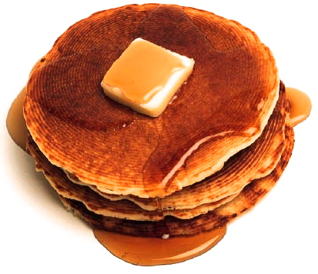
Maybe I should eat some pancakes.
2
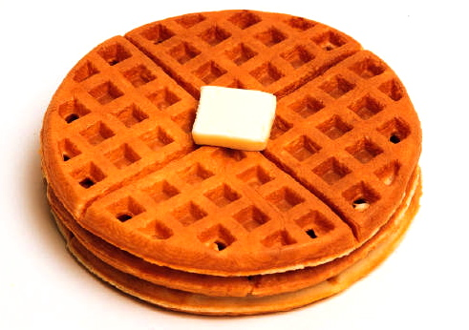
Maybe I should eat some waffles.
3
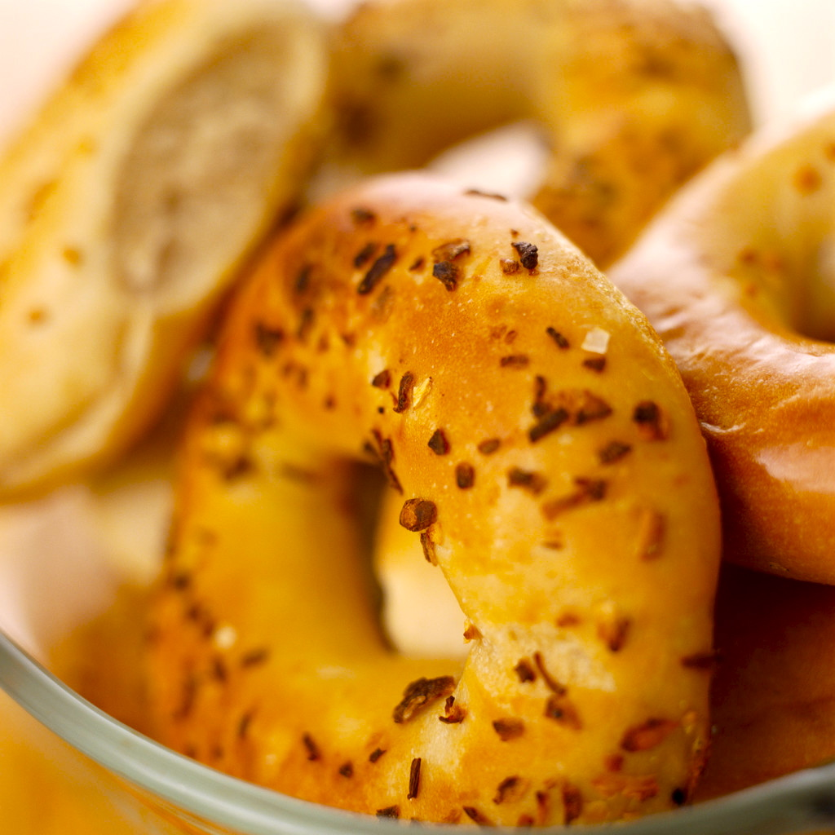
Maybe I should eat a bagel.
4
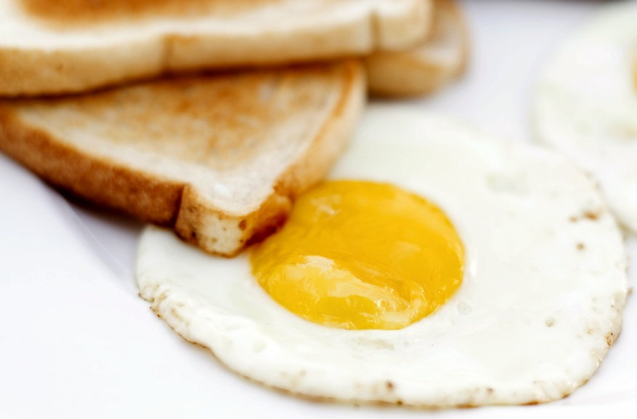
Maybe I should eat an egg and some toast.
5
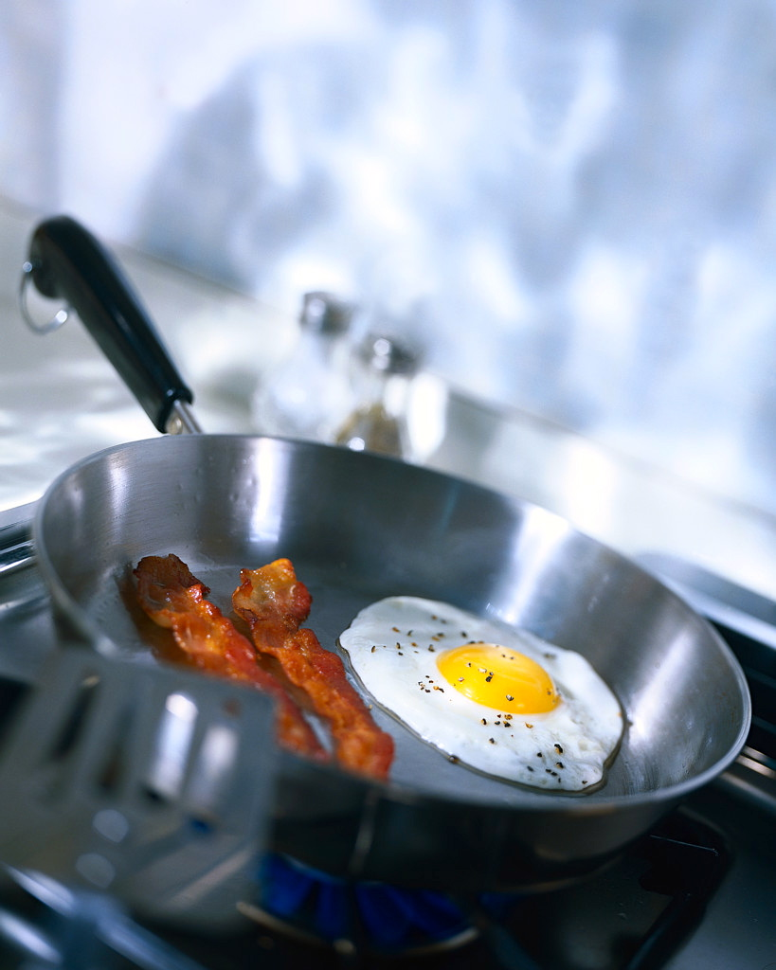
Maybe I should eat an egg and some bacon.
6
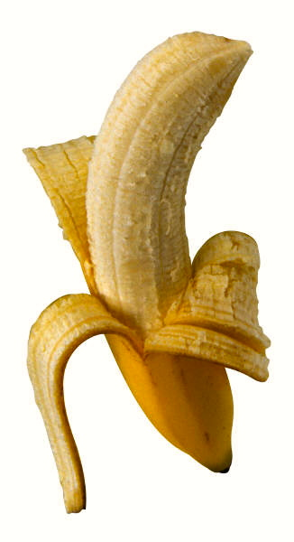
Maybe I should eat a banana.
7
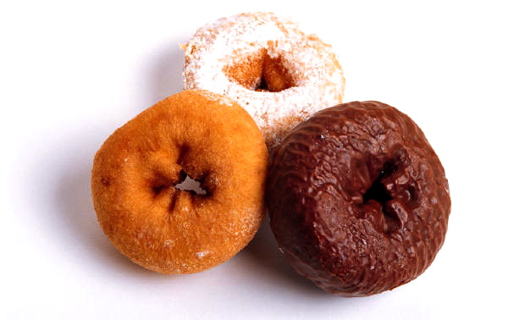
Maybe I should eat a doughnut. What do you eat for breakfast?
More free ebooks and stories are available at www.clarkness.com and www.readinghawk.com.
Text Copyright © 2013 by Clark Ness. Images are from Microsoft Office Images unless otherwise noted.
Permission is granted for printing, photocopying, emailing, recording, storing in a retrieval system, and transmitting this ebook in any form, or by any means, mechanical and/or electronic. Sale of this ebook and/or uploading it to a commercial bookstore or commercial website is strictly forbidden without prior written permission.
8

