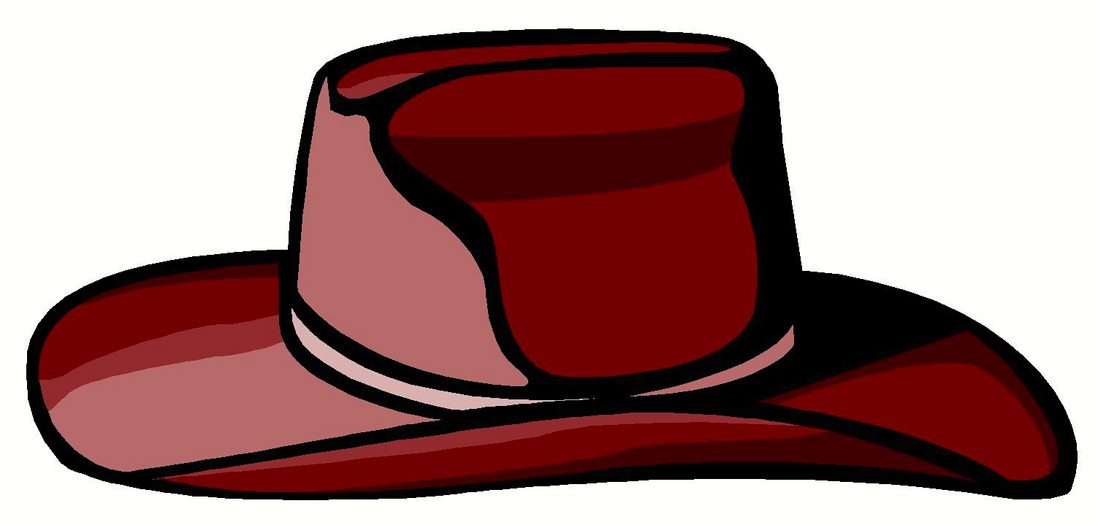
A Person
Can Wear
By Clark Ness

Visit www.clarkness.com and www.readinghawk.com
for more free ebooks and stories.

Reading Level: Lexile® Measure 200L
Flesch-Kincaid Grade Level 0.7

Nonfiction
A person can wear a hat.
1
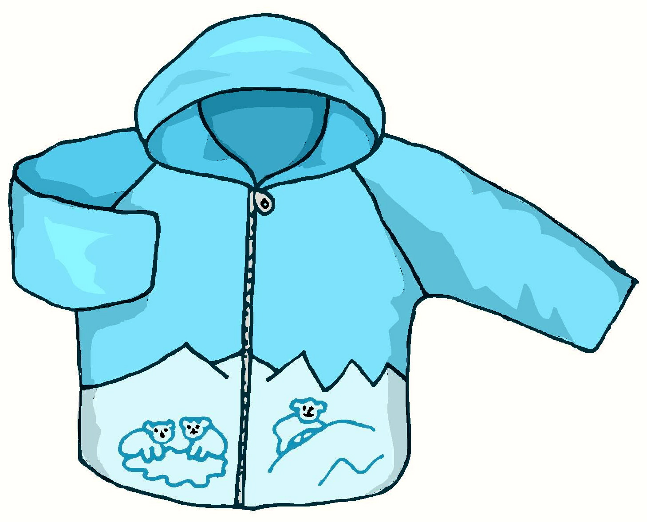
A person can wear a coat.
2
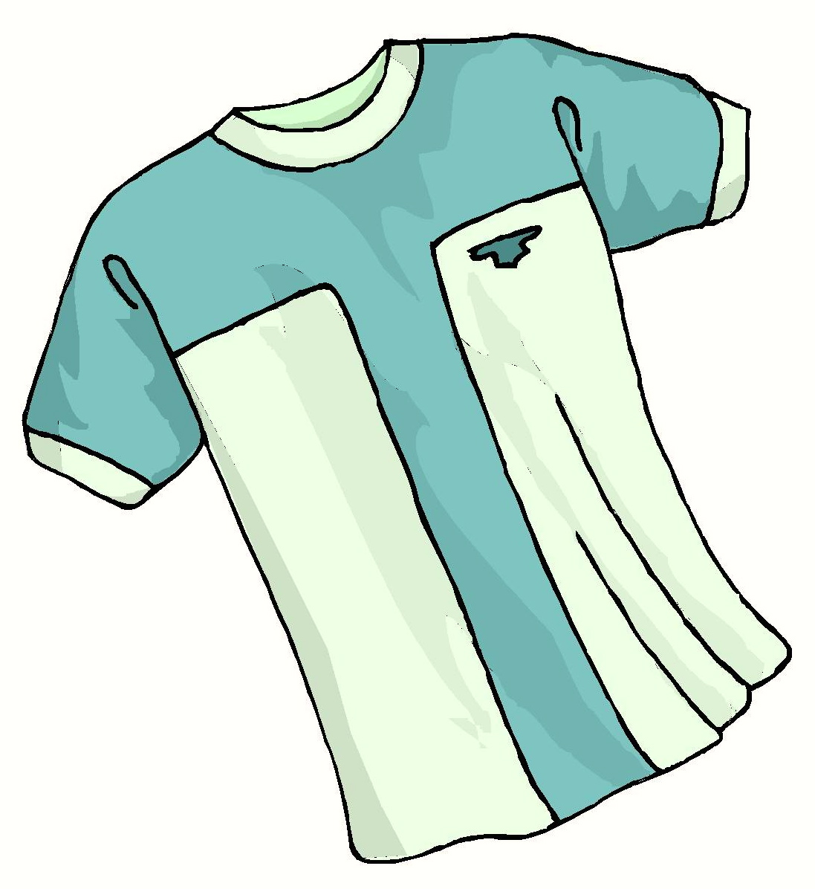
A person can wear a shirt.
3
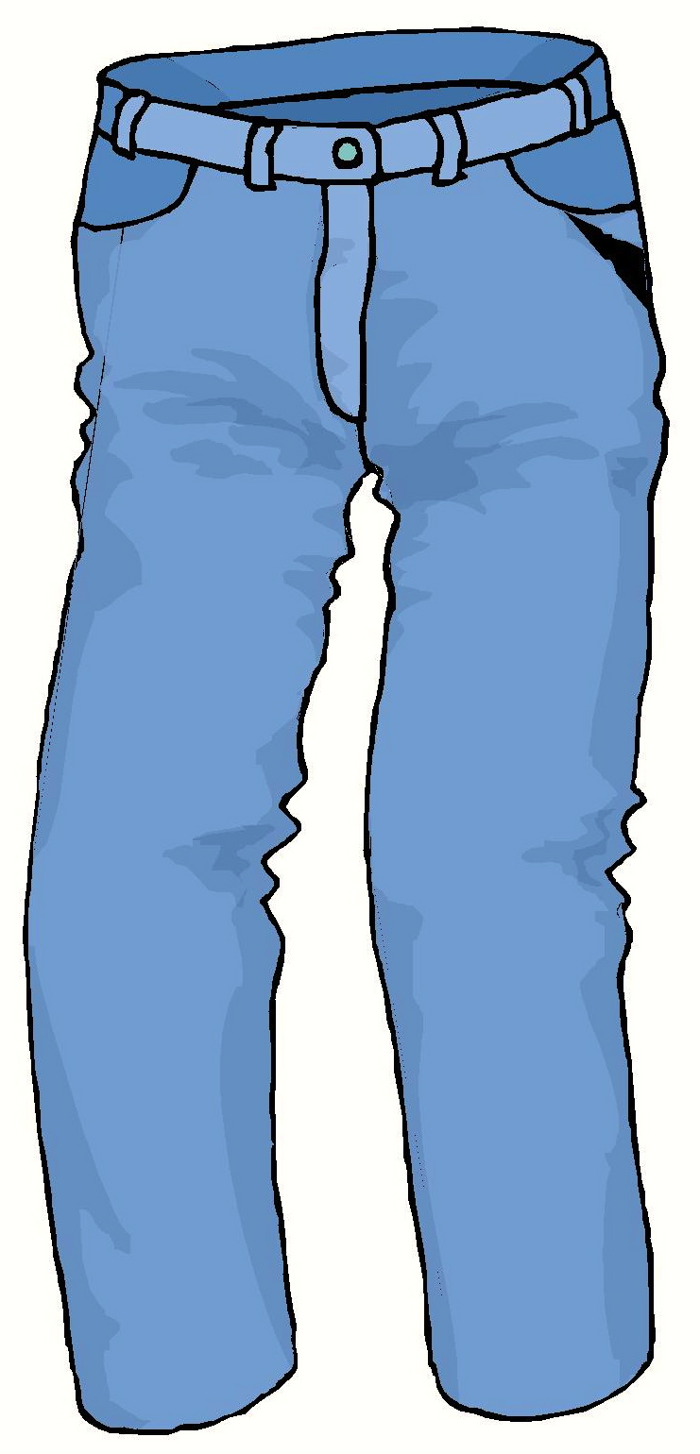
A person can wear pants.
4
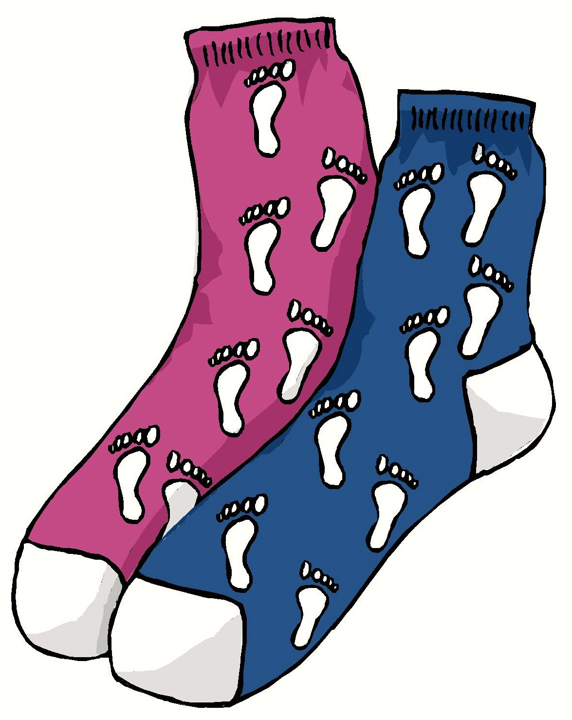
A person can wear socks.
5
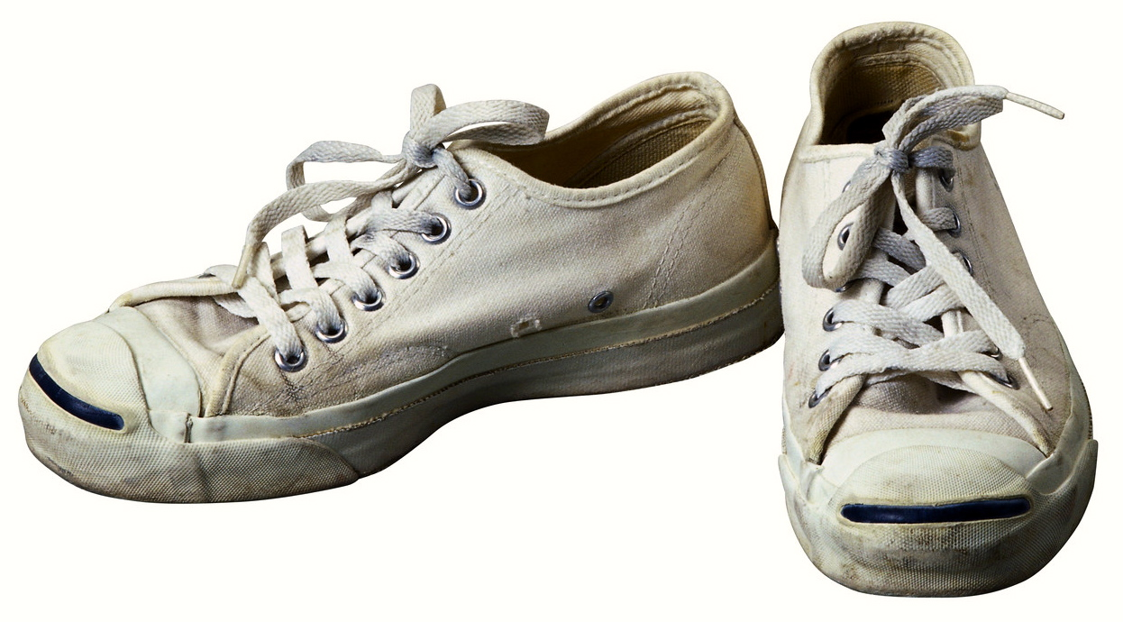
A person can wear shoes.
6
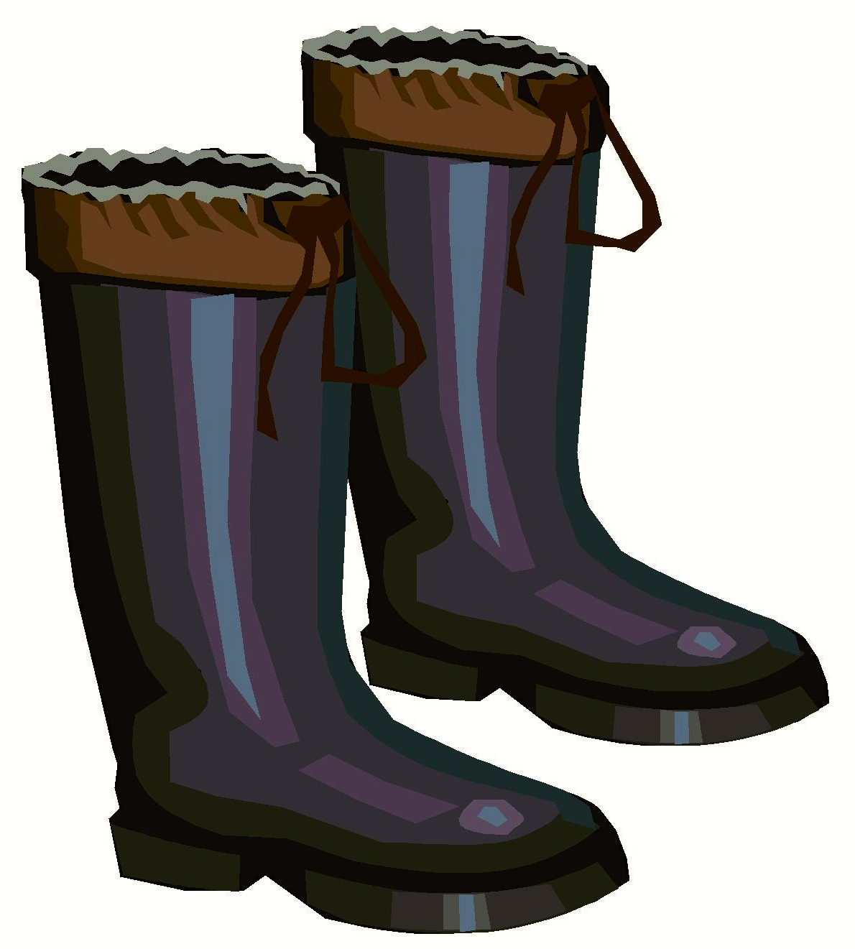
A person can wear boots.
7
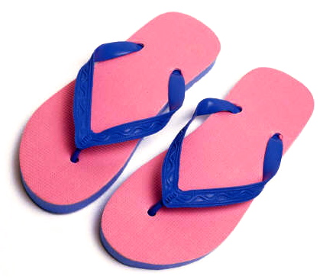
A person can wear flip-flops.
More free ebooks and stories are available at www.clarkness.com and www.readinghawk.com.
Text Copyright © 2013 by Clark Ness. Images are from Microsoft Office Images unless otherwise noted.
Permission is granted for printing, photocopying, emailing, recording, storing in a retrieval system, and transmitting this ebook in any form, or by any means, mechanical and/or electronic. Sale of this ebook and/or uploading to a commercial bookstore or commercial website is strictly forbidden without prior written permission.
8

