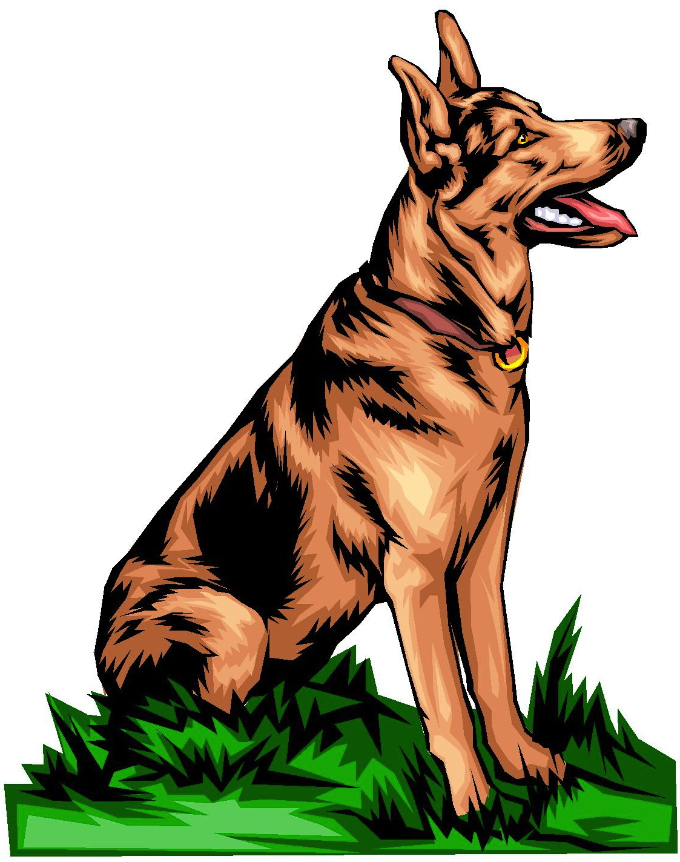
A Dog Can Sit
By Clark Ness

Visit www.clarkness.com and www.readinghawk.com
for more free ebooks and stories.

Reading Level: Lexile® Measure -80L
Flesch-Kincaid Grade Level 0.0

Nonfiction
A dog can sit.
1
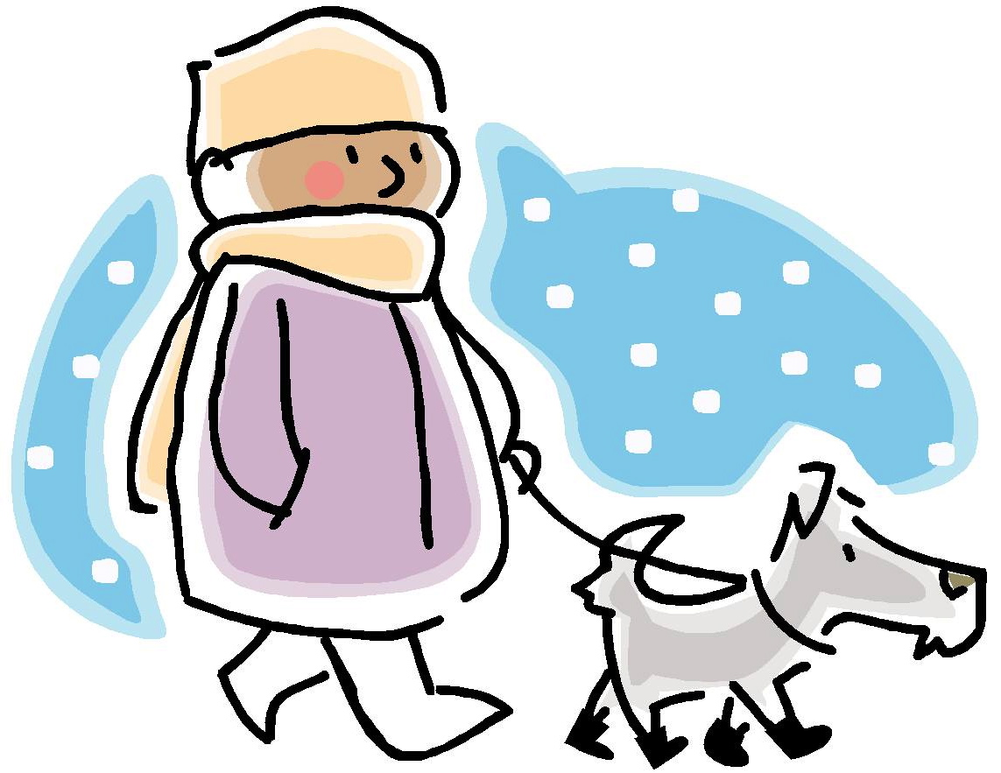
A dog can walk.
2
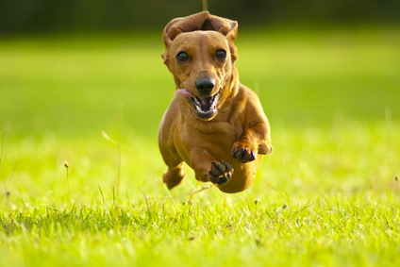
A dog can run.
Photograph © ANDREW NORRIS - Fotolia.com
3
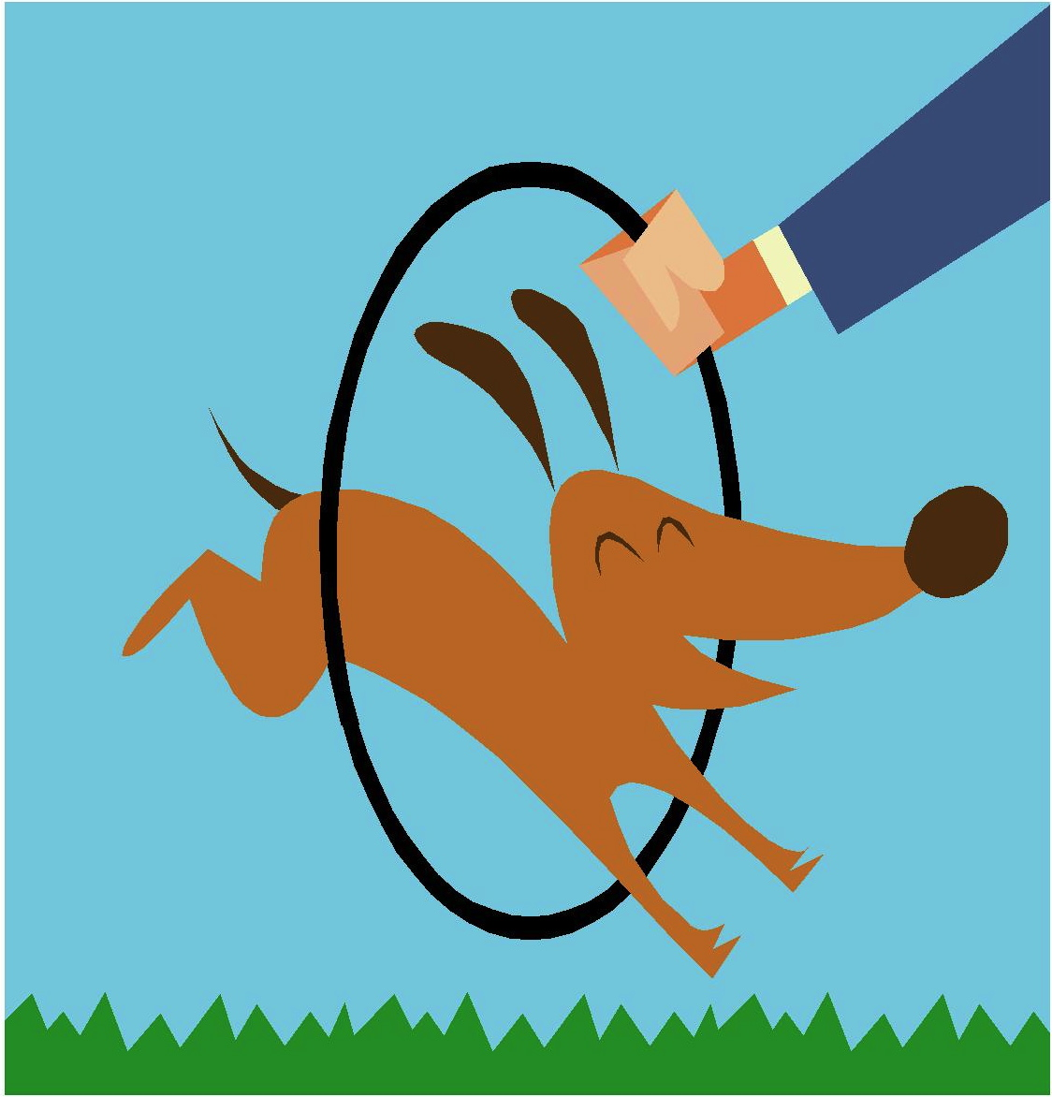
A dog can jump.
4
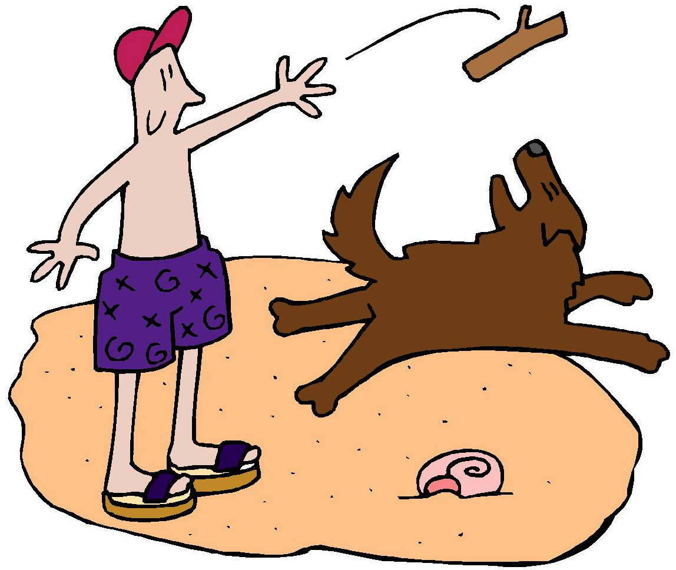
A dog can play.
5
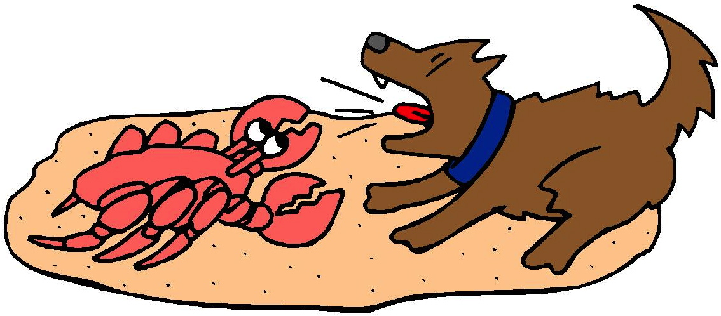
A dog can bark.
6

A dog can eat.
7
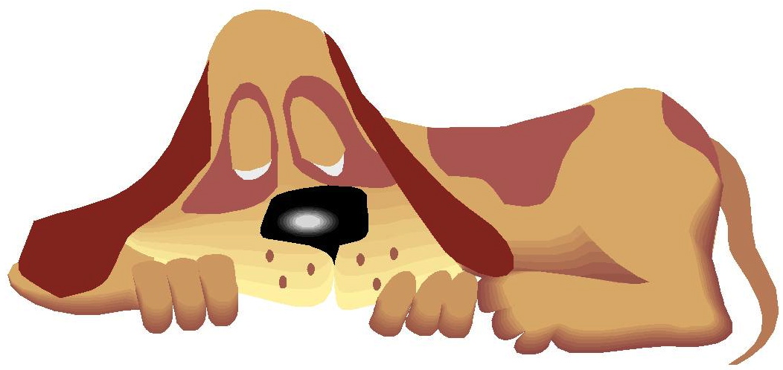
A dog can sleep.
More free ebooks and stories are available at www.clarkness.com and www.readinghawk.com.
Text Copyright © 2013 by Clark Ness. Images are from Microsoft Office Images unless otherwise noted.
Permission is granted for printing, photocopying, emailing, recording, storing in a retrieval system, and transmitting this story in any form, or by any means, mechanical and/or electronic. Sale of this story and/or uploading to a commercial bookstore or commercial website is strictly forbidden without prior written permission.
8

