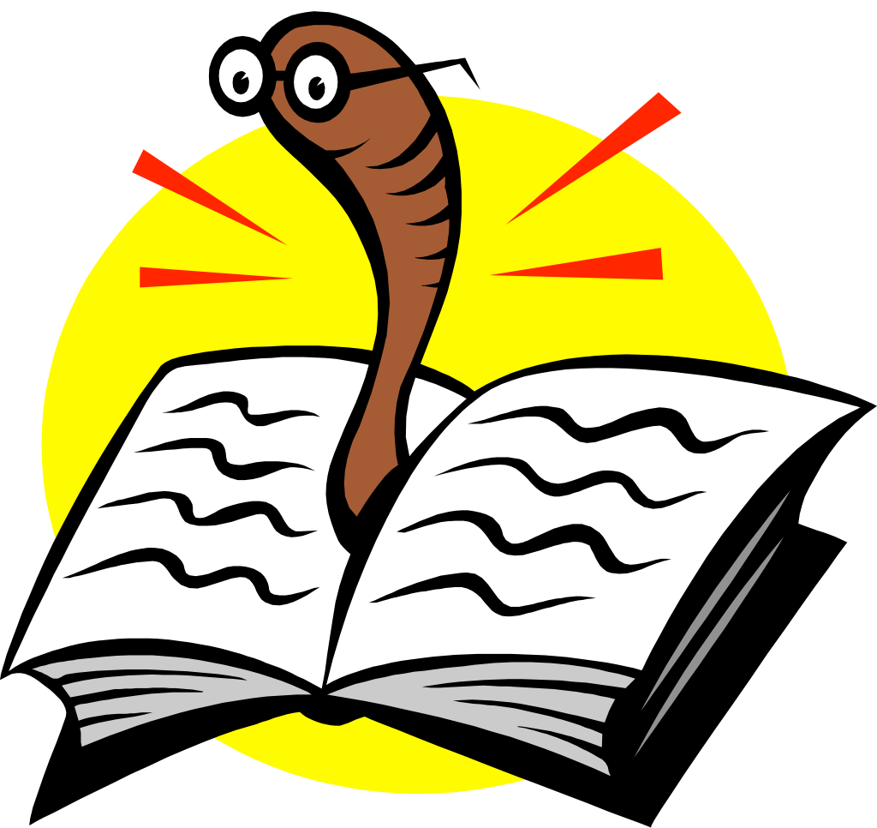
A Book
By Clark Ness

Visit www.clarkness.com and www.readinghawk.com
for more free ebooks and stories.

Reading Level: Lexile® Measure 650L
Flesch-Kincaid Grade Level 2.6

Fiction
The worm read a book about how to live underground.
1
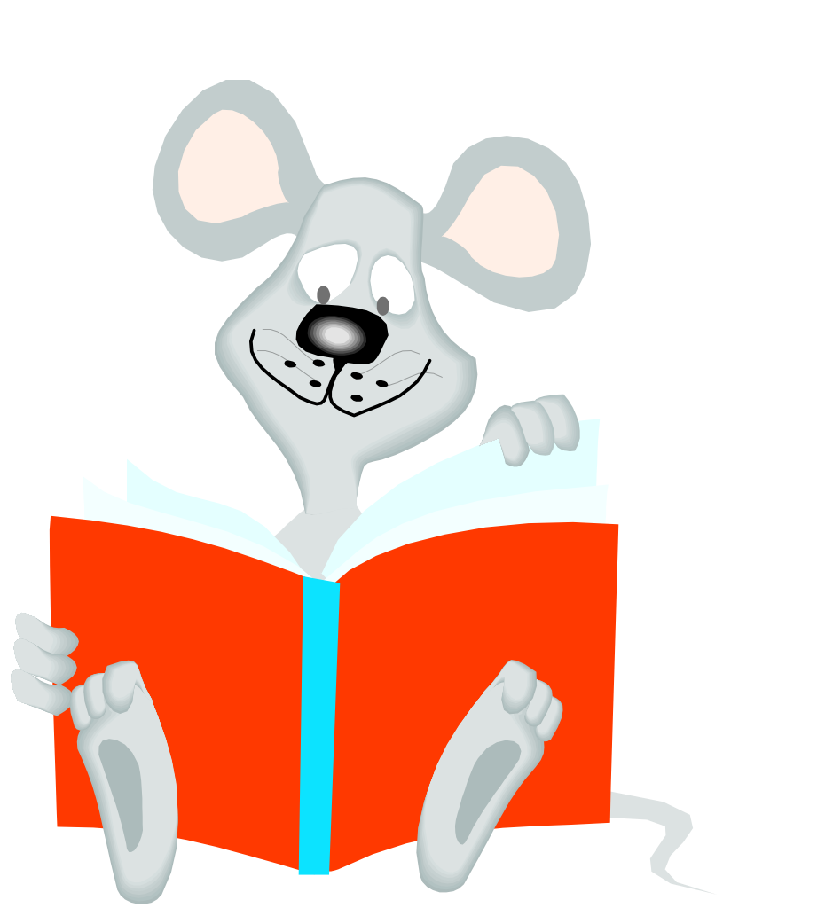
The mouse read a book about how to make cheese.
2
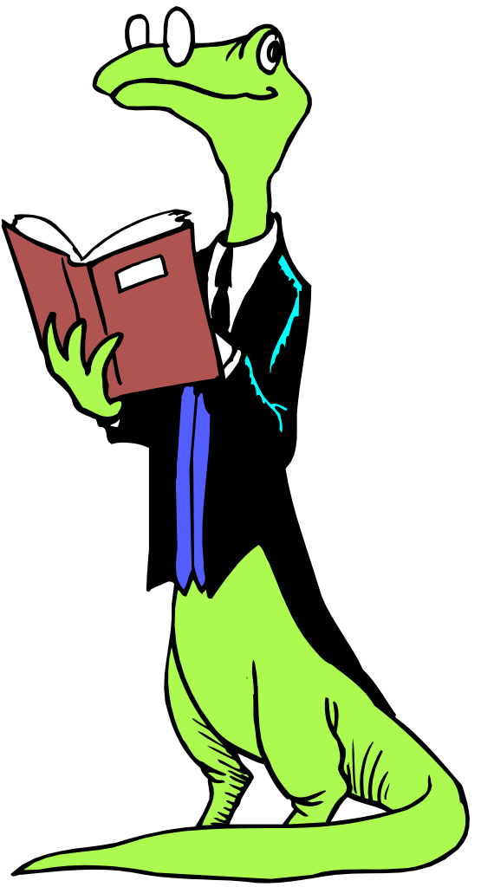
The lizard read a book about how to be a smart lizard.
3
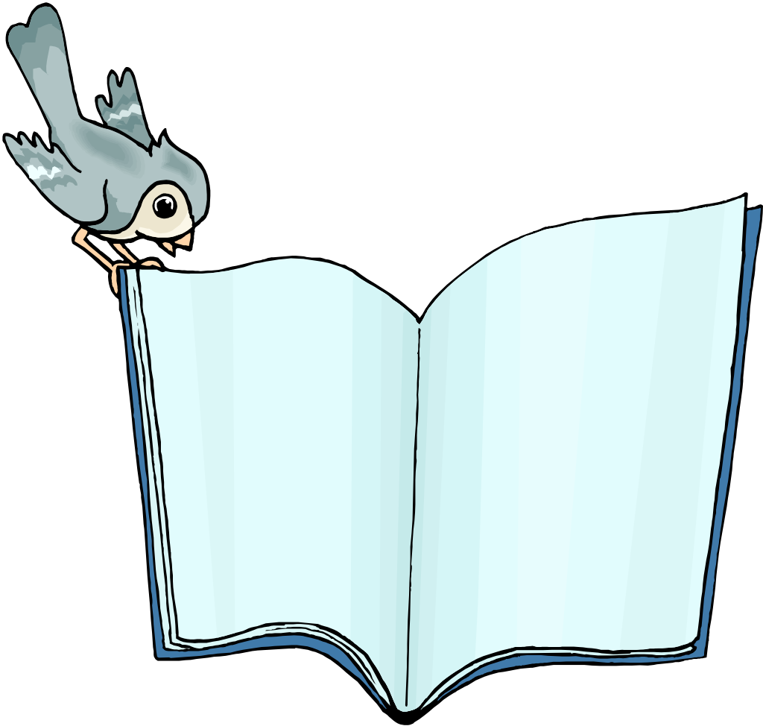
The bird read a book about how to find seeds to eat.
4
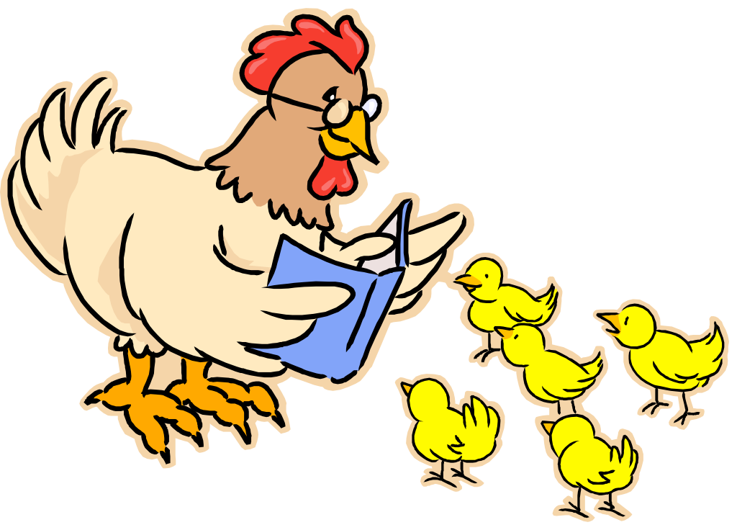
The chicken read a book about how to be a nice chicken.
5
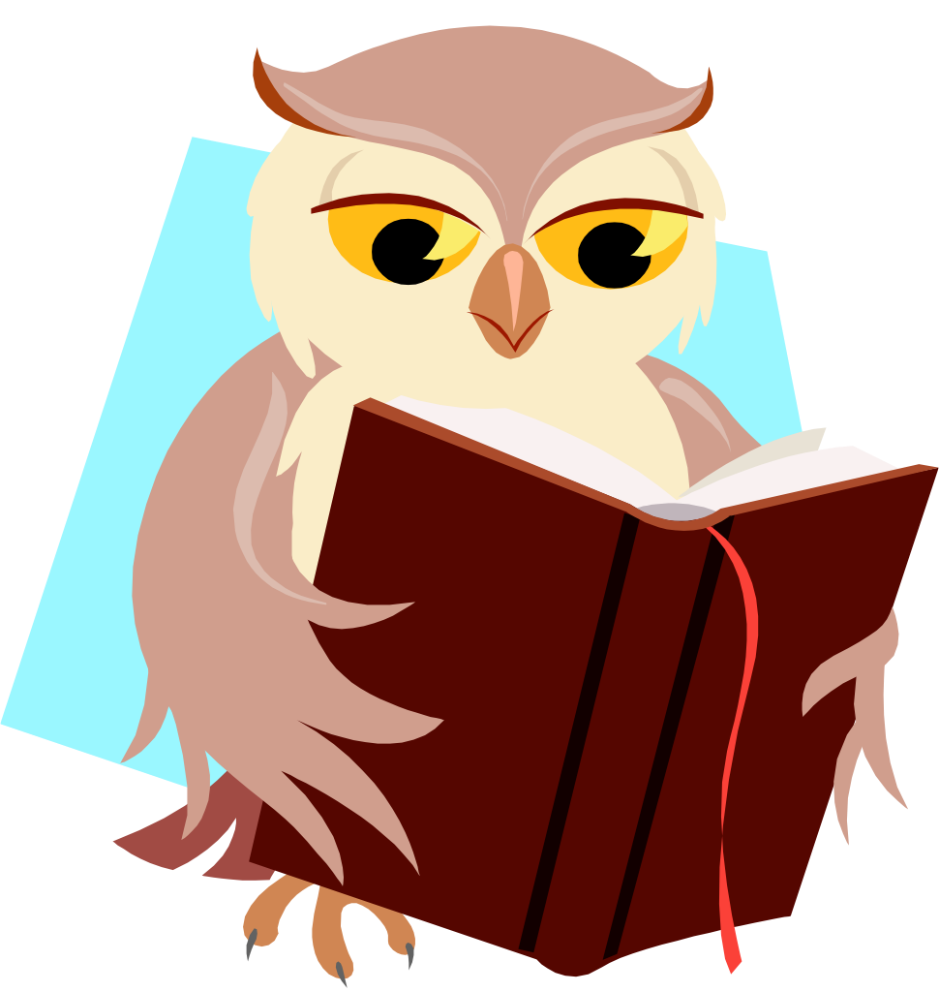
The owl read a book about how to be a wise owl.
6
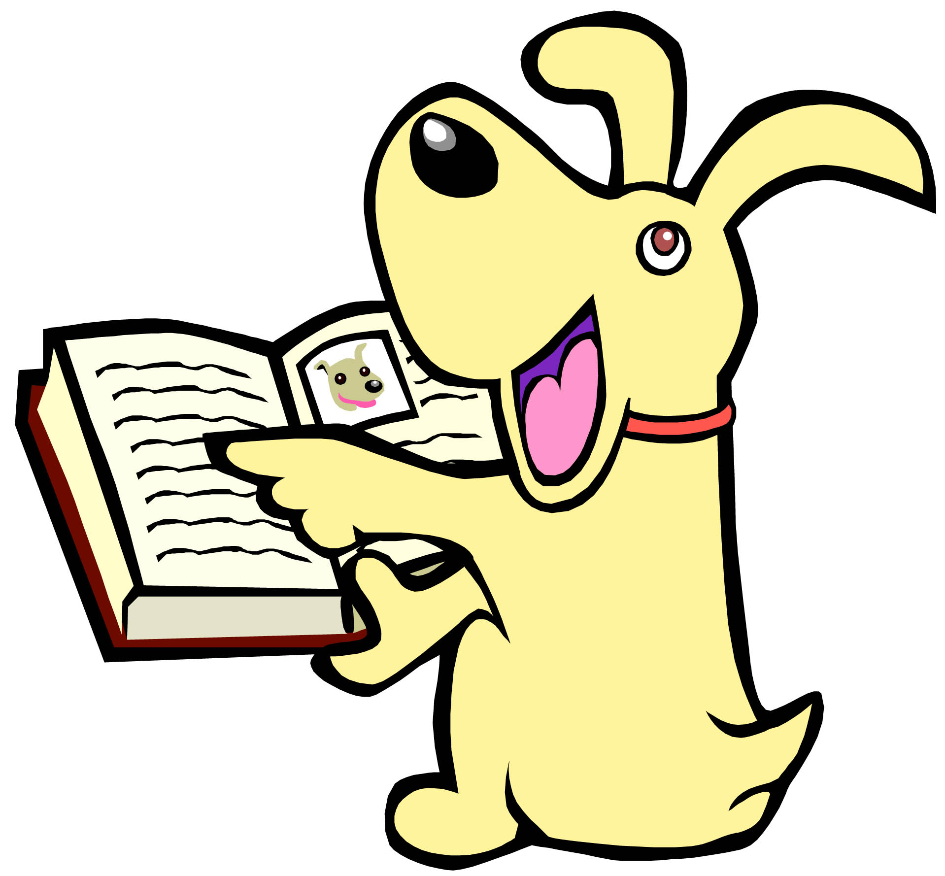
The dog read a book about how to fetch a ball.
7
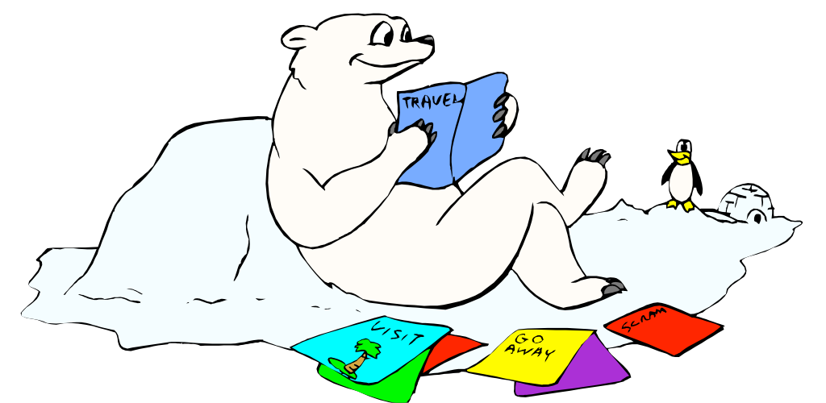
The polar bear read a book about warm places to visit.
8
More free ebooks and stories are available at www.clarkness.com and www.readinghawk.com.
Text Copyright © 2013 by Clark Ness. Images are from Microsoft Office Images unless otherwise noted. Permission is granted for printing, photocopying, emailing, recording, storing in a retrieval system, and transmitting this story in any form, or by any means, mechanical and/or electronic. Sale of this story and/or uploading to a commercial bookstore or commercial website is strictly forbidden without prior written permission.

